Multimeter PCB Project Notes
Christopher Kalitin
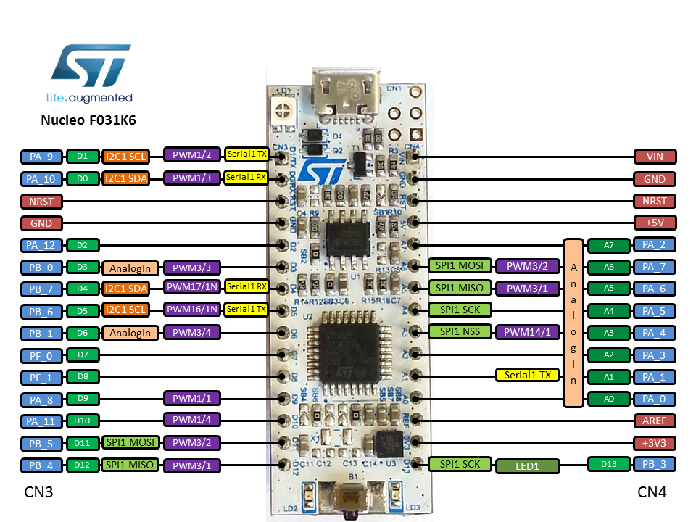
Project Update 1:
https://x.com/CKalitin/status/1916710999799091414

Initial PCB:
https://x.com/CKalitin/status/1924717786905096429/photo/1

USB Bridge and LDO:
https://x.com/CKalitin/status/1925029852555706783/photo/1

Apr 27 2025 - Capacitance Meter
https://grok.com/chat/7c62a970-2d8a-4364-bcbf-b9c15ef00f24

Three methods for determining capacitance:
- Time Constant with a DC Pulse, t = RC
- Sense output current (AC), V = IZ, V = sqrt(R + 1/wC), solve with 4 variables
- Voltage divider (AC), V_out = V_in * (Z_c)/sqrt(Z_c² + R²)

1. Time Constant:

The time constant isn’t too easy with orders of magnitude different capacitors. We need sufficient resolution on the time axis of the voltage graph to determine where voltage goes to 0.37% of its original value. Maybe fit a polynomial?

Eg. 1K and 1uF = 1ms time constant - 1000 samples/second would just barely get it. We need to be extremely fast.

Also, 1nF capacitors exist, at 1K we get a 1us time constant, 1,000,000 samples/second is the bare minimum.

1M resistor is an option, then at 100uF you get 100s time constant. Possible but unreasonable.

100k good compromise?
1nC * 100k = 0.1ms
100uF * 100k = 10s

If we take a small step size (not the full 0.37 fall off) then it’s possible even with a 10 second time constant, then ADC resolution would be the limiting factor. Can’t get better than 12 bits over the full 0-3.3V range (remember you can’t actually use the full range).

We’ll need at least 10k samples per second, and store these! Wavelet compression YES!!!! It’s not actually required here but I want to implement it somewhere!

Probably best to use a MOSFET to toggle high voltage instead of a DAC.

MOSFET 3.3V -> R -> C -> ADC1

2. Current:

V = IZ
Z = sqrt(R² + Z_c²)
V = I * sqrt(R² + Z_c²)
sqrt ((V/I)² - R²) = 1/wC
1/(w * sqrt ((V/I)² - R²)) = C

$\frac{1}{ω\sqrt{({\frac{V}{I})}^{2} - R^{2}}} = C$

V is RMS, as with current. Can’t use max because of erroneous values and rms exists for a reason.

DAC -> Resistor -> Capacitor -> Resistor (for current) -> GND
^ ADC1 ^ ADC2 (treat GND as 0)

With this setup we Need 3 pins (or 2 if we assume DAC is accurate), could be characterized with a test pin and delete the ADC there, but more fun to implement automatic characterization too (eg. on startup).

V=IR, we assume R is known (want a high precision resistor here) and we can observe V as the difference between ADC2 and GND to solve for current.

Omega is a constant that determines how we generate our AC signal with the DAC. w = 2pif. Grok says a square wave is also possible? We don’t need negative voltage right?
Holy shit that’s why AC works! If it’s always positive it’s always moving forward?! Wow!

Record:
Voltage, current (RMS)

Parameter:
Omega, resistance

Note that resistance in the equation is the sum of the RC circuit and then the current sense resistor afterwards.

3 pins required. Would be nice to integrate capacitor sensing with the other functionality (header pins removable to change functionality? Switches that are labelled!)

3. Voltage Divider:

V_out = V_in * (Z_c / sqrt(Z_c² + R²))

DAC -> Resistor -> Capacitor -> GND
^ ADC1 ^ ADC2

Simpler than option 2, more complex than option 1.

This one just relies on impedance with an AC signal. What is impedance anyway? From first principles.

What are the determining factors of precision here? For both AC options.

Capacitor range: 1nC -> 100uF. 5 orders.

We’re measuring RMS voltage and it’s always changing, will the ADC perform well? If it does reasonably, we don’t even need too high a sample rate, no time constant limitation here.

The limiting factor is if we can get good RMS voltage readings. Maybe average could be more useful? And we’re comparing average voltage to average current/voltage so it’s fine if they’re both measured in the same way (average or RMS, only slight difference).

Let’s test.

1. Time Constant Testing

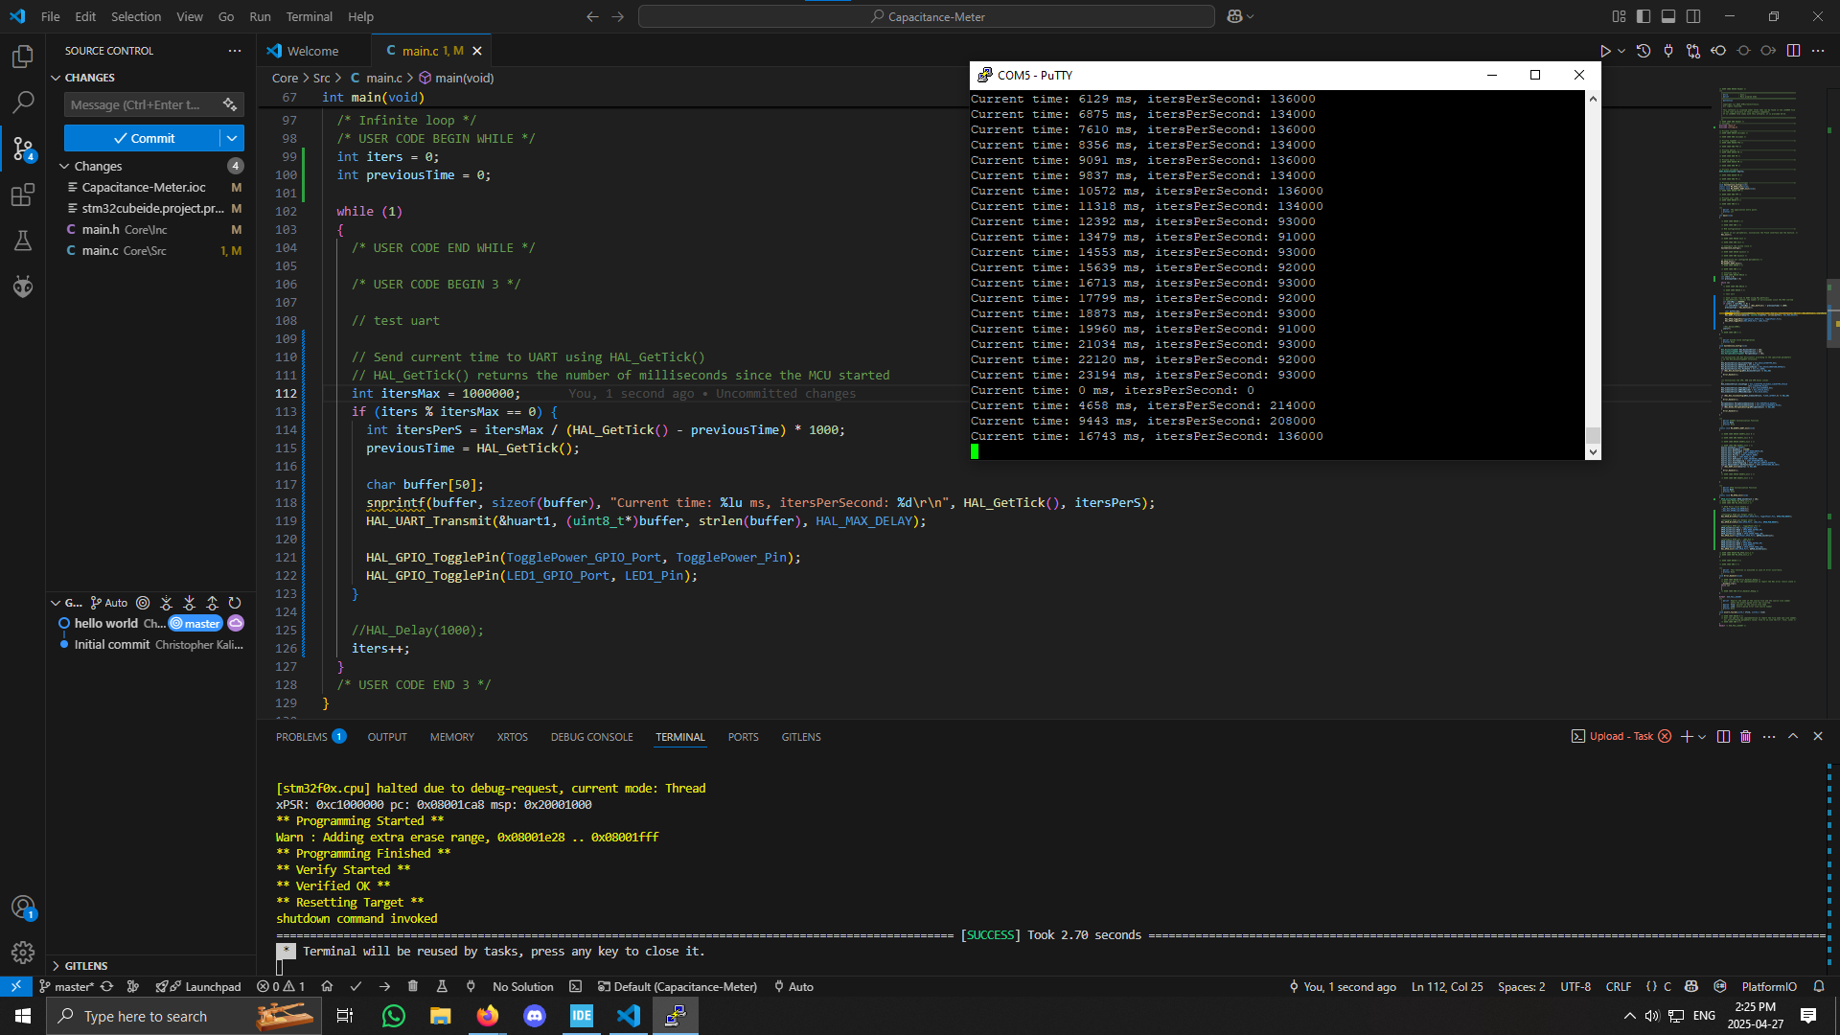
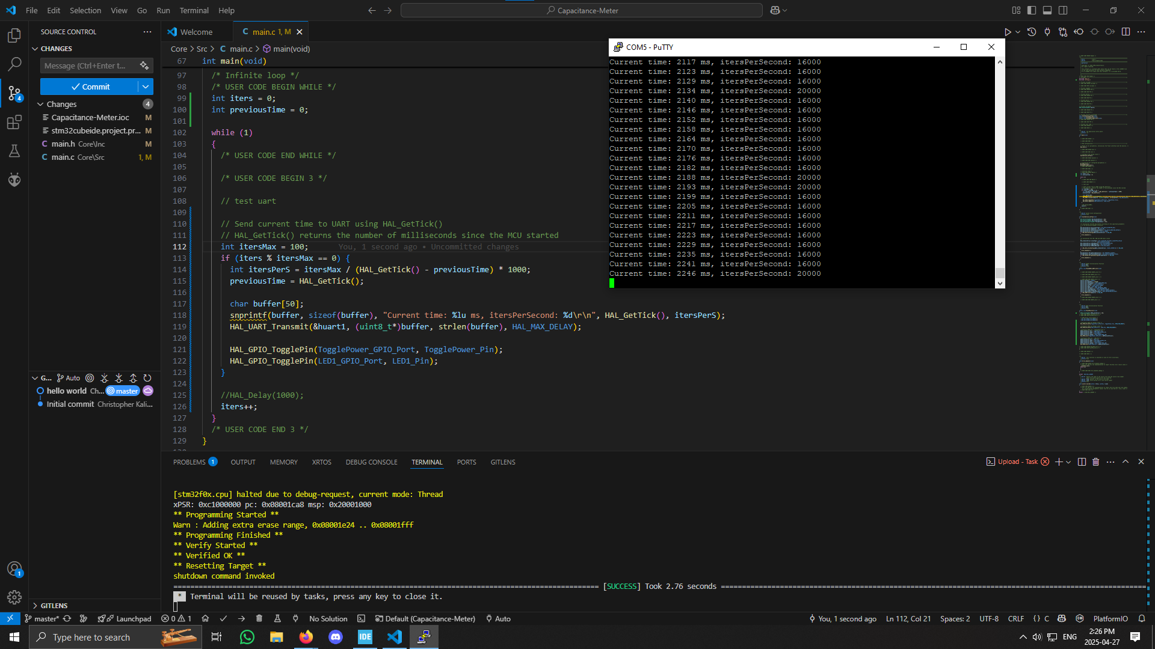

Counting time between adding to a constant, then sending how many counts we got per second.

Counting to 1 million: ~200,000 iterations per second.
Counting to 100: ~20,000 iterations per second.

Looks like we’re fast enough for the time constant method.
If time constant = 0.1s we would get 20 iterations minimum, which is not great but reasonable for the 1nC low end.

If we’re running the ADC as fast as possible in the background using DMA, we might be fine. More testing required. Also need accurate timestamps for the ADC.

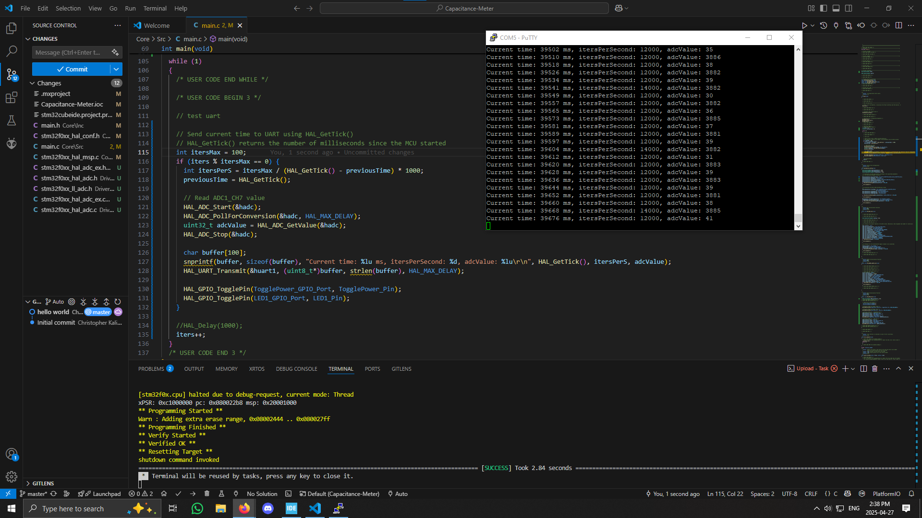

Putting an ADC Poll in the code drops the 100 count to ~13,000 iterations per second.
Measuring the GPIO to gate of P channel mosfet here.

If polling ADC and UART printing on each iteration we get 200 per second (5ms in between prints).

With 10uF and 100k:
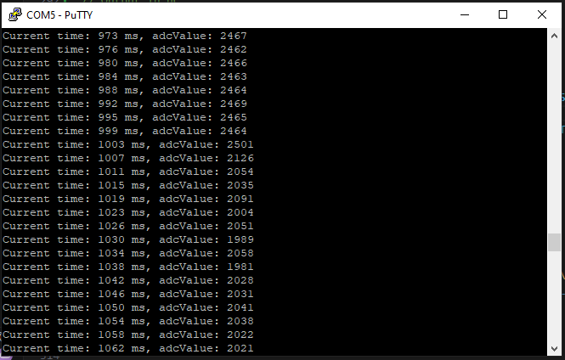

It should discharge over a second whats happening is the adc being treated as ground? It shouldn’t be.

Even with a 100uC it’s the same.

Had an LED on there, oops. I didn’t understand the circuit I created.

It’s working now, needed a very different setup than what was expected. R and C need to be in parallel between drain and GND so that after drain is disconnected from 3V3, charge can flow between capacitor plates. GND is still connected but no full current path there so this has no impact on the capacitor. The goal is to make both plates equal potential, which is done by discharging through the resistor.

With a 100uF I see about 1 second time constant. Good news.

V(t) = V(0) * e^{-t/RC}
-t / (R * ln(V(t) / V(0))) = C

Just tested and got 2% error, great success.
https://docs.google.com/spreadsheets/d/1yhi5X4qD3KZGuxgbmgw0fRGMHKAdRkSt20LZqGnqzSA/edit?usp=sharing

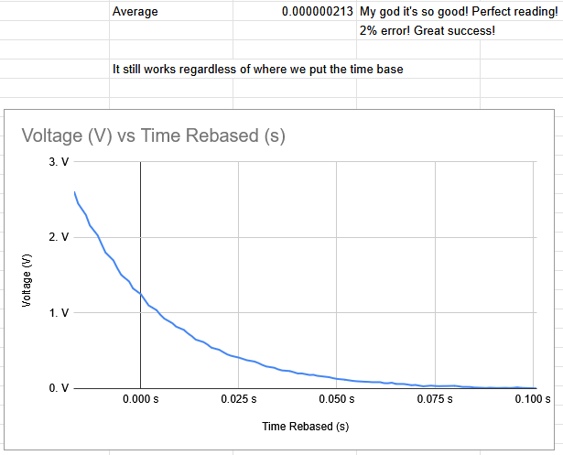

It still works regardless of where we put the time base. This is with a 0.22uF from the TV.

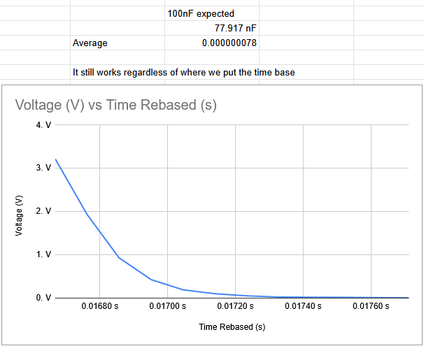

With a 100nF capacitor (10k pico farads) we get ~10 data points and are well off. This is after using the timer to record time in microseconds, could even get eighths of microseconds if need be. Would need 3 extra decimals though, with a 32 bit number we could be fine.

Need to implement a custom timer read function to get time since it overflows every 65.535ms. For most accurate time in microseconds we get 4300 seconds of use until even the 32 bit time overflows. Up to 64 bits? Not bad from a memory perspective for a single timer.

My STM32 F031K6T6 has no DAC shit.

2. AC Current Technique

Using ESP32, 8 bit DAC

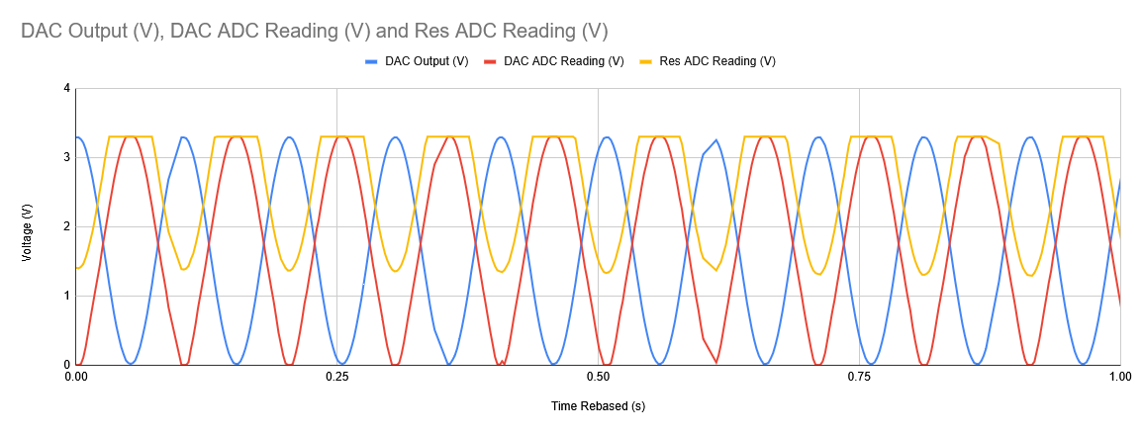

Note that with frequency = 10 we don’t get the full 10 in a single second.

$\frac{1}{ω\sqrt{({\frac{V}{I})}^{2} - R^{2}}} = C$

DAC -> Capacitor -> Resistor (100k) -> GND
^ DAC ADC ^ Res ADC

V/R = I
V/100,000 = I

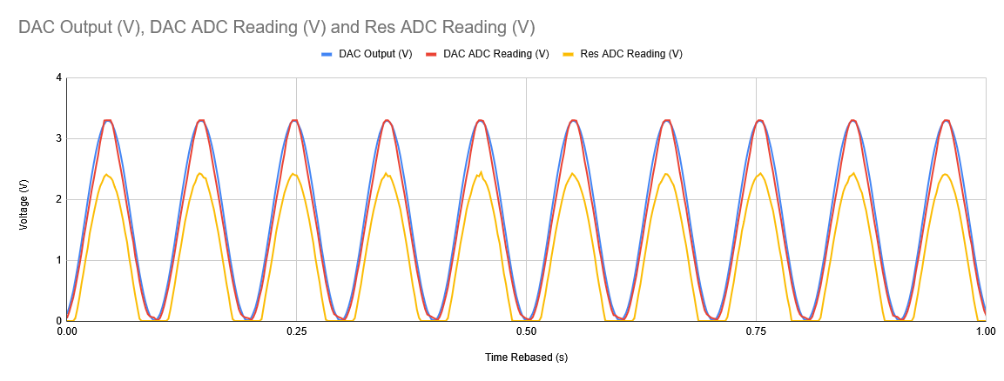
This graph is with w = 10 and with 10uF.

Res reading is getting cut off by a good amount, negative voltage somehow?

We are getting negative voltages! Remember the phasor diagrams! Wow I independently came to this!

This is with w = 0.1:
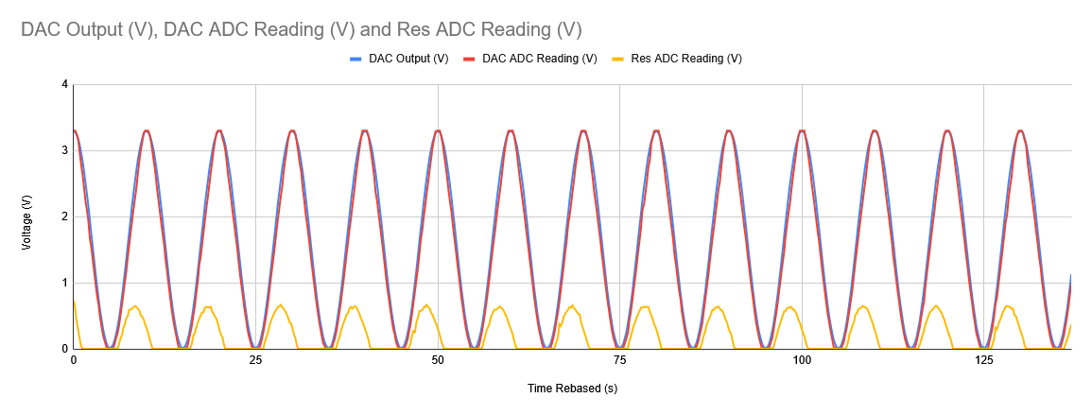

Decreasing omega leads to higher capacitive reactance, so the voltage drop over the capacitor is greater, which is exactly what we see!

Also, I saw voltage get down to around -0.26 on the multimeter.

Compare max current to max voltage, not average or RMS since I can’t observe negatives.

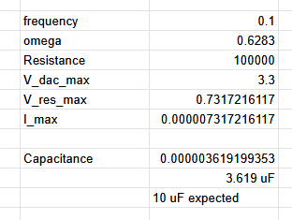

This technique didn’t work, maybe RMS is required.

3. Voltage Divider

V_cap = IZ_cap
I = V_in / Z_net
V_cap = V_in * (Z_cap)/sqrt(Z_cap^2 + R^2)

$C = \frac{\sqrt{1-(\frac{Vout}{Vin})^{2}}}{(\frac{Vout}{Vin})Rw}$

DAC -> Capacitor -> Resistor -> GND
^ ADC1 ^ ADC2

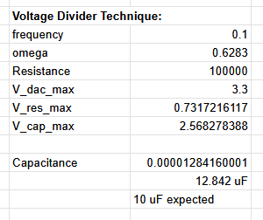

More successful, but I need to account for negative voltage somehow. Can I?

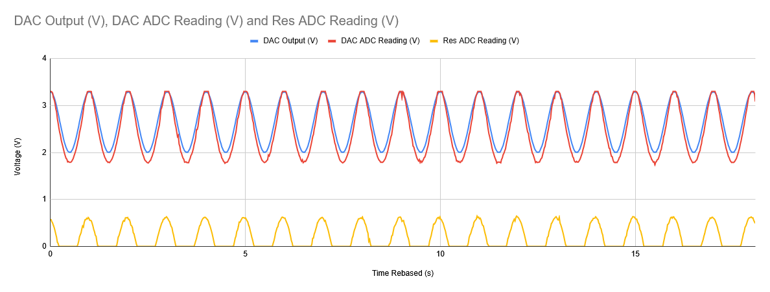
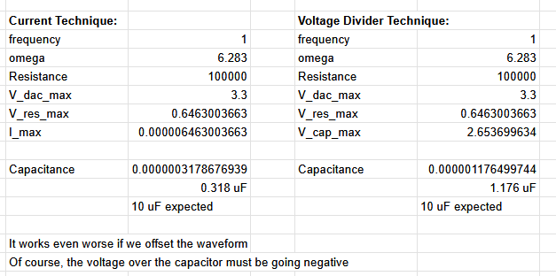

Even by offsetting the input voltage the negative issue isn’t solved (intuitively obvious).

DC method is best.

Apr 28 2025 - Ohmmeter & Inductance Meter
https://docs.google.com/spreadsheets/d/18XtmGChiUFf5-_KOeM2cW_4XBRlJEHJwaLndttZrfAg/edit?usp=sharing

Todo Today:
- Resistance Meter
- Inductance Meter

Resistance meter requires current reading, so characterize the single resistor constant voltage method.

V/I - R_sense = R_test

I = V/R_net

I_sense = I_net = V_sense / R_sense
V_sense = V_in * (R_sense / R_net)

With the 3V3 pin I’m getting 3990 ADC value. On GND I’m getting 20-150, strange noise. Maybe an ADC on each side of the sense resistor is required.

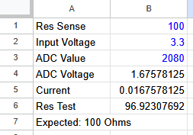
Expected: 100

Next, shower so I can go down stairs to get the multimeter with some respect for myself.
Also, test ADC on both sides of resistor.

I’ll need to write an ADC reader that includes the characterization.

Ammeter mode on my multimeter doesn’t work. Got the new multimeter.

Resistors are +/- 1%

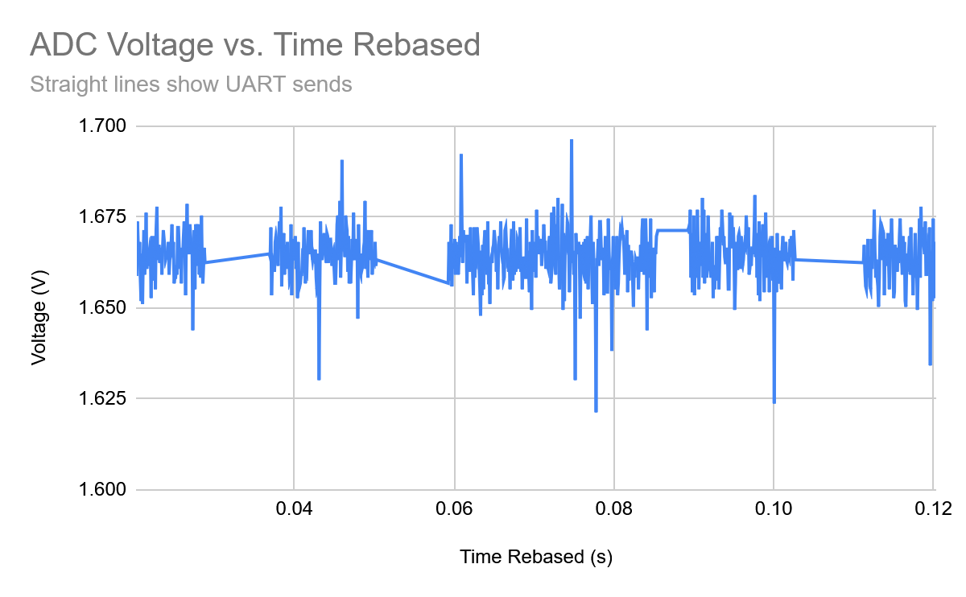

As always, the ADC reading is extremely noisy, in about a 0.25V range this time. The straight lines show when UART is sending, peripherals are required with DMA to fix this.

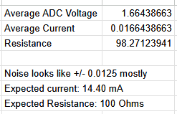
Taking the average voltage value we get a current of 16.6mA from 14.4mA from the multimeter. This is about the error I expect from the ADC reading.

With multimeter I see about 1.645 V, though it’s still very noisy.

We’re within 15% on current and 2% on the resistor.

The current issue could be getting the wrong 3V3 voltage. Multimeter reads 3.22V, this takes the resistor reading to 93 ohms, not ideal.

Btw it’s called an ohm meter.

Inductance Meter:
Best method is probably a DC pulse and observing the charging/discharging pulse to find time constant then using t = L/R.
RL circuit where voltage over the inductor is:
V_L = V_in * e^{-t/tau}

Another option: finding the resonant frequency of an LC circuit (would be decaying in reality).
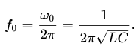
$L=(\frac{1}{C})(\frac{1}{2πf})^{2}$

Best way to do this is probably detect zeroes, divide by two, see how many in a second.

Reasonable range of frequencies: 1 Hz, 1000 Hz. 3 orders.
Corresponds with LC = 2.533e-2, 2.533e-8. 6 orders better.

Inductor range: 1uH -> 1H

The one I salvaged is probably 2.2uH.

Capacitor value: 0.02533F

Not ideal, lets try 10-10000 Hz:
LC = 2.533e-4 -> 2.533e-10
C = 0.0002533 F

My setup of 2.2uH and 220uF is 7234 Hz. Will be extremely difficult to see any oscillations.
With a 1mF cap we’d get 3,393 Hz.

For series RLC circuit time constant = L/R
Extremely difficult to get a high time constant would need literally 0.1 ohms or something. 1uH capacitor is just barely possible with 1 ohm resistor, and the lines have resistance losses too.

Just across the power rail with a jumper on each end, there is 8.6 ohms of resistance.
It’s just not too reasonable to add a inductance meter.

Apr 29 2025 - ADC Characterization

Strategy:
- Put potentiometer on 5V and run across 0-3.3V range.
- Record Multimeter value and ADC value
- Fit polynomial

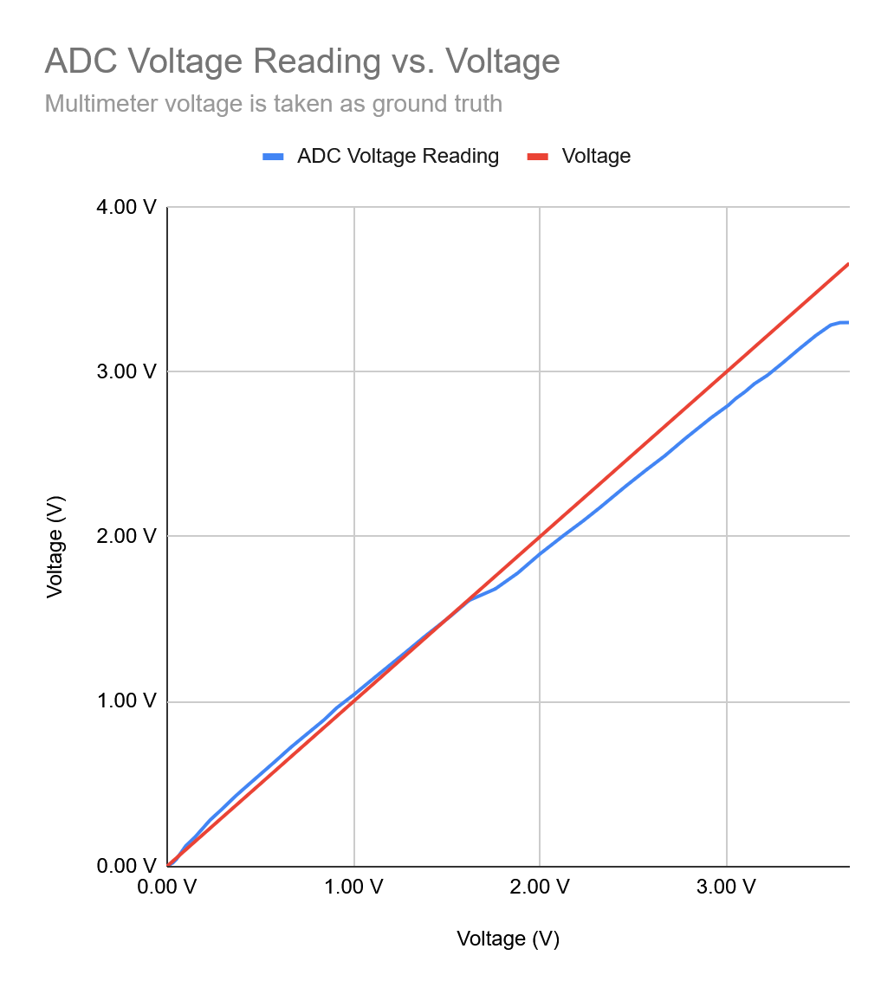

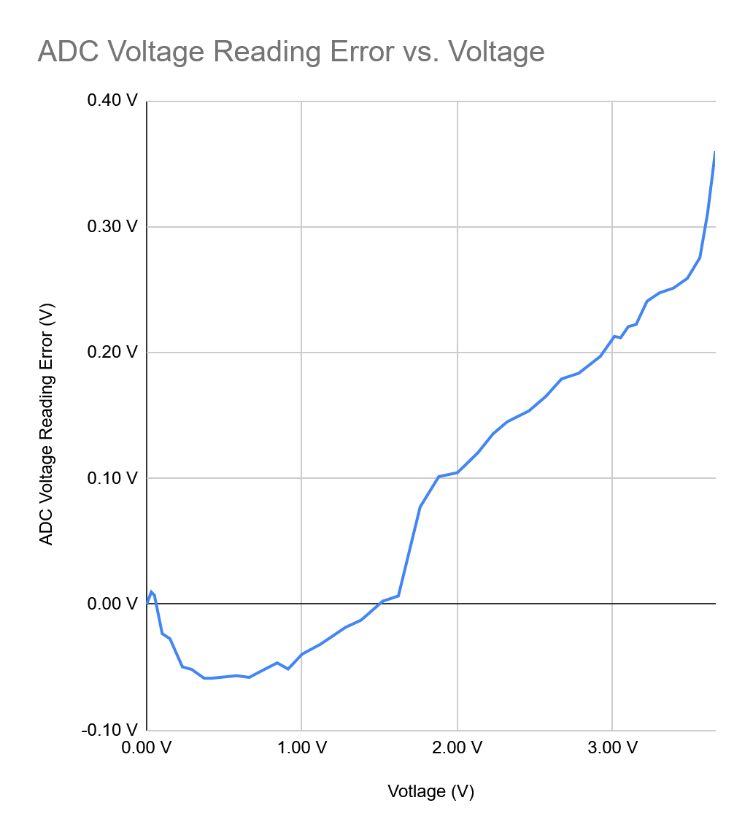

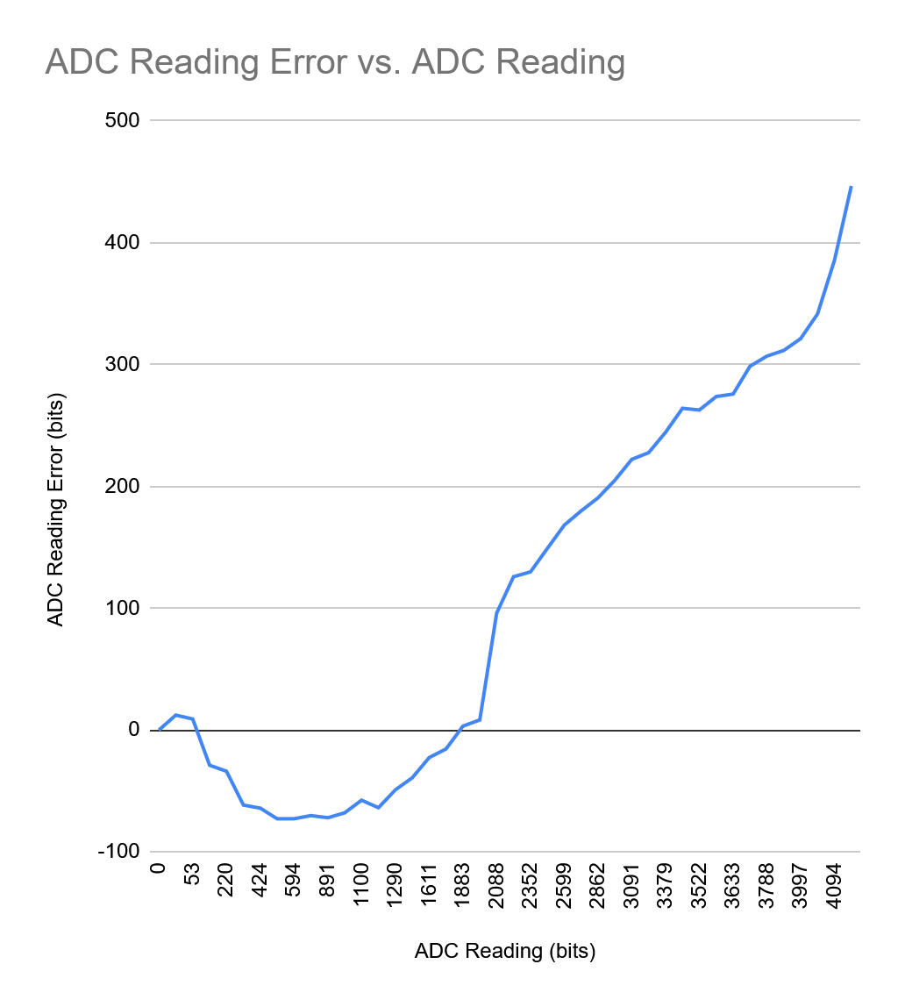

Fitting the polynomial in Google Sheets isn’t actually working (Desmos doesn’t give the same thing back). Using this site instead: https://arachnoid.com/polysolve/. Strangely, all looks like on the google sheets chart, but not on desmos.

Floating point arithmetic is extremely slow so I’m multiplying everything by 1E11, using an int64, then dividing by 1E11. No floating points and slight speed increase.

It felt like it was 10x slower with the float error term implemented, now maybe 2x faster than float when using *1E11 and int64.

Still super slow, will need to apply the error term as little as possible.

Printing issues:
C/C++ Build → Settings → Tool Settings → MCU GCC Linker → Miscellaneous

Under Linker flags, add:
-u _printf_float -u _printf_long_long

Still not working, I’m giving up for the night.

Remember Feynman’s Algorithm:
- Write the problem down
- Think really hard
- Write the solution

Apr 30 2025 - Double Multimeter Characterization
“[ESP 32 ADC] results are not linear after 2.5V.”
https://youtu.be/u-1TRpLGH04?si=VmZx0zg__dxrRTU-

Both were similar I think I have a google sheet for it.

May 14 2025 - Practicing SMD STM32 Soldering
My approach was to put solder paste on the pads (just a little bit), then put on a ton of flux, then line it up, then heat gun.

Feels like I heated it up way too much, try less and then go for a pass with a soldering iron afterward.

Had several shorts I wasn’t able to solve, this might be because I am using the chip I shorted on Solar to practice. Next up, real one.

I’m paranoid about solder bridges under the MCU since the pads extend back to there. Try to keep it not halfway over the pads but just barely touching for when you go over with the heat gun. This only solves two of the sides though, the other two, no way to solve me paranoia.

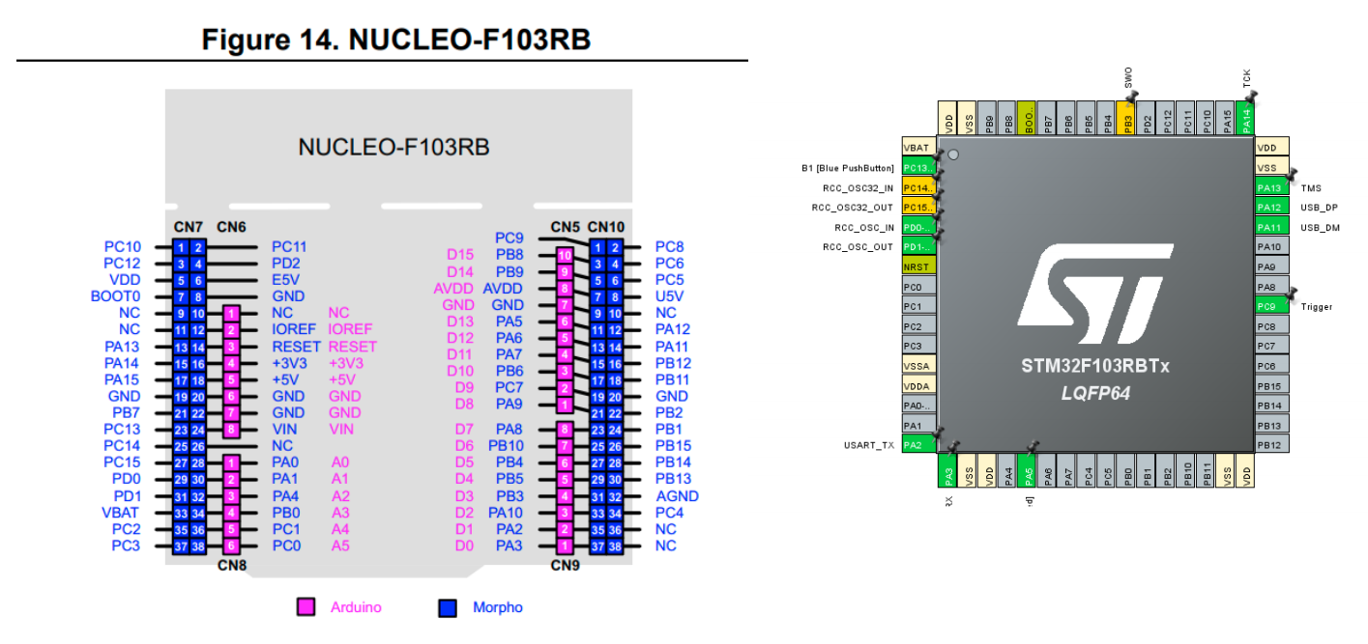

I just did the soldering iron this time.

Pins 28 and 29 are shorted. This is VDD and PA4.

Now 27 and 28 have 100 ohms between them. 32 and 33 is 20 ohms.
27 and 28 are VSS and VDD.

3.3V / 100 Ohm = 0.033mA eh not horrible but also why is there a connection between these two, I’ll test the other pins

40 and 41 have 90 ohms between them (Left bottom VSS and VDD), maybe this is usual.

Every single VSS, VDD pair has ~100 ohms between them, except VSSA and VDDA.

Cleaned it and no shorts. Great Success!

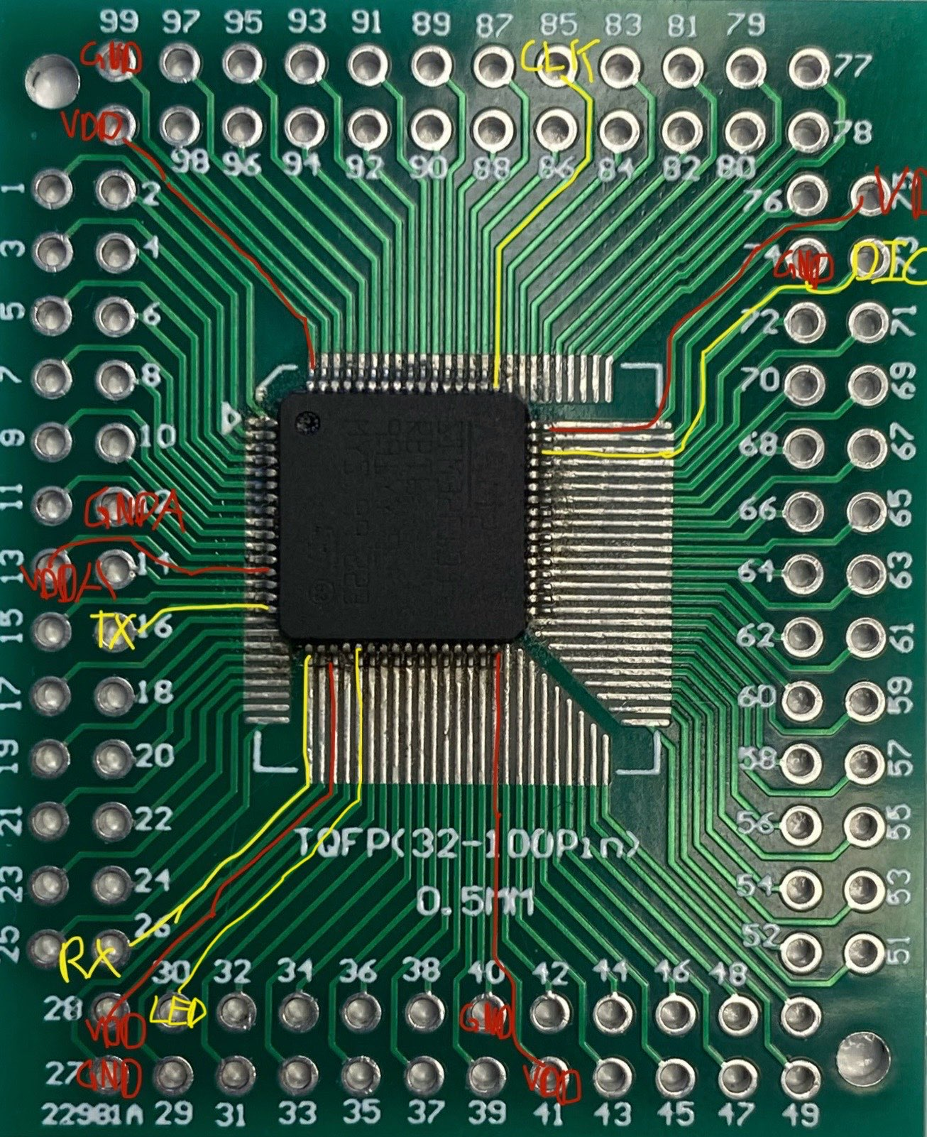

Now I got it all set up and the ST Link shuts down whenever power is connected to the STM32, 7 ohms of resistance between GND and VDD. Short? Note that I’ve taken the board off the backing breadboard I assembled with the paper clips, so it’s the chip itself that is shorted.

It starts pulling ~500mA, then resets the ST Link. Obviously a short. I took out the capacitor there too in case it was a short somehow (well the breadboard on its own didn't make the st link reset, so this wasn’t the issue).

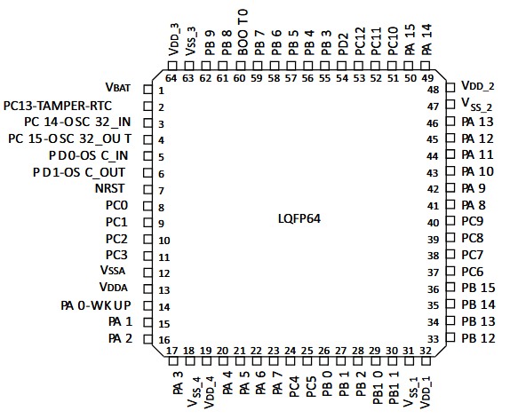

https://electronics.stackexchange.com/questions/123703/which-of-these-marks-signifies-pin-1-on-the-stm32f-lqfp64
“if the text is right-side-up, pin 1 is in the lower left”

Did I just get that wrong? No, I soldered it right.

Now confirmed again by seeing on the bottom where the VDD and VSS.

Now on the same board with the MCU desoldered, we still get tons of shorts.
Eg. 28-27, 30-31, 35-36, 36-37

This is all from solder under the MCU, which is why these testboards are extremely shitty.

Now, after cleaning it off, it’s all fine.
So, my strategy has to be completely soldering iron with no paste at all, only on the very end of the pins so it doesn’t get under.

Lmao thought it was shorted together, then realized I’m doing this on a breadboard. Retard!!!! I found one!!

May 18 2025 - Ok lets make it flash today
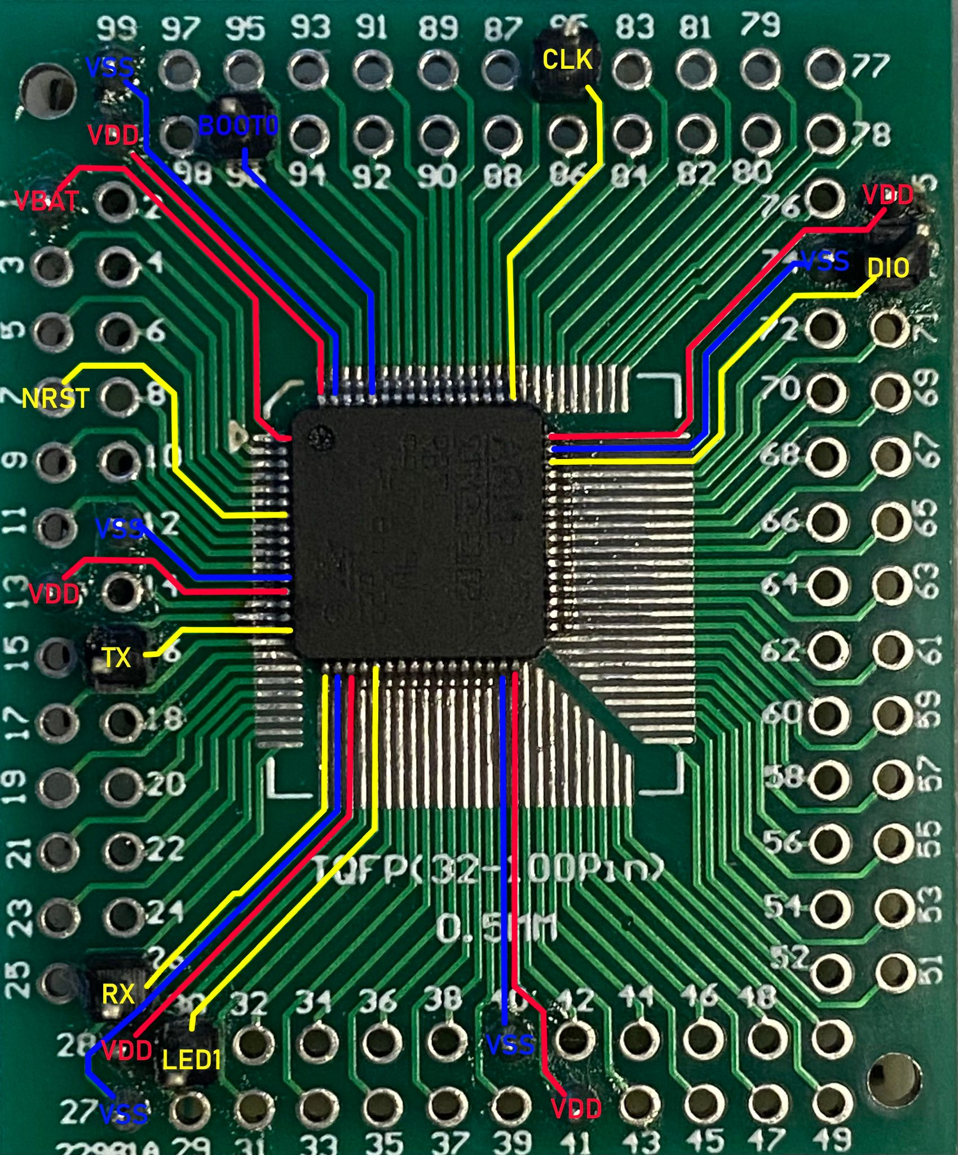

The krita image for this is on the STM32-Projects github.

Didn’t flash, see this grok conversation and the videos:
https://grok.com/chat/52ccab4d-222b-4716-8128-e0824bbe22d0

May 19 2025 - Getting into PCB Design for Rev1
https://www.youtube.com/watch?v=jx0dryLmUEQ

Current sensor options:
- Hall effect IC
- Shunt Resistor

Burden voltage = voltage drop in current sense mode.

Example of using a shunt resistor on the Solar pack at 60A 134V max:
V_{shunt} = IR
V_{shunt} = 60 * 0.001
V_{shunt} = 0.06 V

P_{shunt} = IV
P_{shunt} = 60 A * 0.06 V
P_{shunt} = 3.6 W

If using an op amp to amplify current sensor or shunt resistor voltage, pay attention to its typical offset figure. If you’re inputting a low enough voltage into an op amp, it’ll just get lost in the noise of the typical offset figure.

Looking on Digikey, the only shunt resistors rated for >25A are the physical metal tab types.
Eg. https://www.digikey.ca/en/products/detail/koa-speer-electronics-inc/PSF4NTEBL500F/12728476

For this type, it’s difficult to find them at 10mOhms on Digikey, usually far lower.

For a 60mV range from the shunt resistor, and a 12-bit STM32 ADC with 0.8mV, we get 75 steps, 0.8 A precision. Terrible! We currently get ~140mA.

We need a 10x or 100x amplification, or a higher shunt resistor resistance but that means even higher power and voltage drop (getting to 120mV if we 2x it, which is too high for comfort).

I’d like to use op amps in my circuit but I haven’t gotten to that chapter of The Art of Electronics yet. Save it for when you know what you’re doing.

Remember that when importing Altium parts you want XXX-N, N for normal
https://electronics.stackexchange.com/questions/378766/altium-what-stands-for-n-m-and-l-as-a-suffix-for-soic-packages

I want a cool name like Joule Thief
Wait tf a Joule Thief is a real thing? It is a way to use all of the potential energy in a battery cell, well beyond what you can usually get.
https://en.wikipedia.org/wiki/Joule_thief

Scribe Rev 1.0 works for now, maybe will keep it.

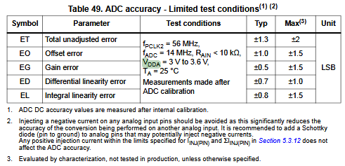
VDDA in the 3 to 3.6 V range shouldn’t impact accuracy too much, now does this impact the max of the range?

For Vref connected to VDDA, put a 1uF or 10nF capacitor between VDDA / VREF and VSSA.
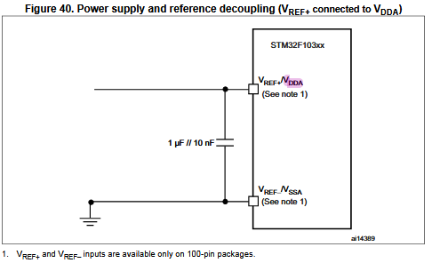

Great explanation similar to what I saw in The Art of Electronics about What VXYZ means
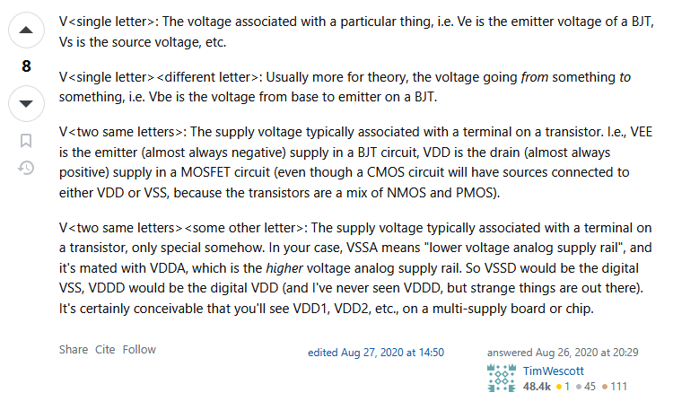
https://electronics.stackexchange.com/questions/518580/what-are-vdda-and-vssa

VDDA is supply relative voltage associated with the analog terminal.

For denoising VDDA I’ll put two capacitors to ground and an inductor (ferrite bead) in series, following Solar’s ECU.
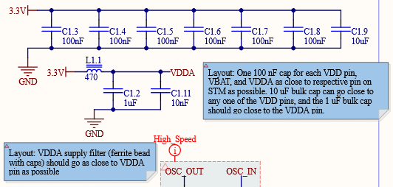

Note: connect the 4.7 uF bulk capacitor to VDD3
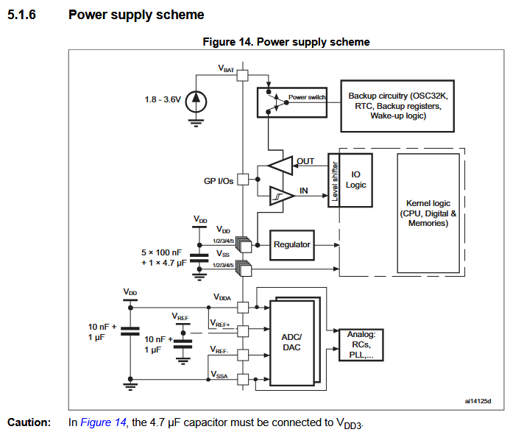

Looks like a 10nF and 1uF capacitor is required on VDDA, with 100nF’s on each VDD pin. It doesn’t show a ferrite bead though?

I’ll go with a 470 Ohm ferrite bead like on the ECU. Or 600, which is what’s in stock on Digikey.

Reset switch should have a 100nF cap for some reason:
https://electronics.stackexchange.com/questions/462988/reset-switch-wiring-on-stm32

100k external pull up / down resistors required on SWDIO and SWCLK.
https://e2e.ti.com/support/microcontrollers/msp-low-power-microcontrollers-group/msp430/f/msp-low-power-microcontroller-forum/1001299/msp430fr2633-do-swdio-and-swclk-pins-require-external-pull-up-resistors

From ECU schematic:
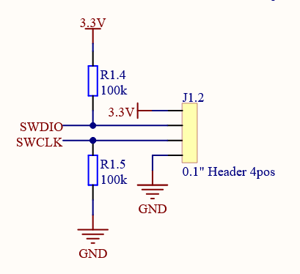

For power I’ll need to step down the USB 5V to 3.3V, I’ll use an LDO
https://grok.com/chat/9eb2e9d5-603d-4878-bf88-f023d9173b74

LDOs are 60-70% efficient.

Power dissipation = IV
At 100mA, 0.1 A * 1.7 V = 0.17 W, reasonable
Since we’re using a USB port we should protect it. Ferrite bead to reduce high-frequency noise from the USB line (600 Ohm at 100 MHz), and a schottky diode to prevent reverse current if we’re powering the board from the 3.3V pin.

Dropout voltage of most LDOs is ~100 to 300 mV, this isn’t an issue for us obv.

Both my Nucleo 64 and Nucleo 32 use F103CBT6 for flashing. Looks like I’ll need to use another MCU for SWD/UART -> USB.

May 20 2025 - USB to UART/SWD Bridge Research
USB:
“If it’s a device leave the shield floating if it’s a host, ground the shield.”
https://youtu.be/PMEpQZ90f34?si=x_usAa1CrThTYQFT&t=2589

I haven’t found too much on using official ST Link software on an STM32 F103CBT6 or F103C8T6 to get UART,SWD -> USB Support. This firmware is proprietary and they have a custom tool for uploading .hex files to your chip. They don’t allow reselling anything with that firmware on it.

Black Magic Probes are an alternative, and apparently support the same STM32’s being used as bridges and flashing to F1 series STMs.
https://mjoldfield.com/atelier/2018/08/nucleo-bmp.html
https://primalcortex.wordpress.com/2017/06/13/building-a-black-magic-debug-probe/

Not clear what the circuit would look like around the STM32 bridge, probably just default power, oscillator, and traces connecting to the target MCU.

Most forum threads where people ask about this end in people recommending you not do it. Very stupid response tbh.

I could use a UART to USB bridge, would be perfectly suitable for my use case, just would be a more involved flashing process with an ST-Link, but this is not an issue.

Reasons to not use a UART to USB bridge IC:
- If I sold this I would want an easier way to update firmware like through a built in SWD/UART to USB bridge, but this shouldn’t be a concern right now.
- I should know how to created an integrated “ST Link” on a PCB, would be useful for Solar.

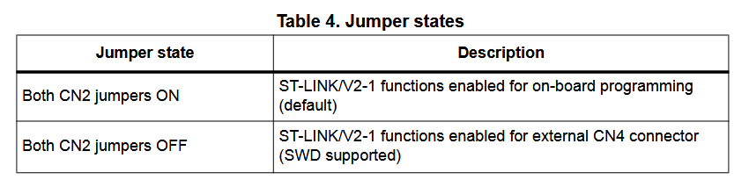
Source: https://www.st.com/resource/en/user_manual/um1724-stm32-nucleo64-boards-mb1136-stmicroelectronics.pdf

I think the jumpers to select ST Link or Target on Nucleo 64’s are used as GPIO inputs into the ST Link STM32, not actually providing current paths for the lines.

There’s an open source ST Link project:
https://github.com/stlink-org/stlink

This is the best blog post I’ve found on creating a custom ST Link, he shows Nucleo schematics too! Very important!!
https://hackaday.io/project/179054-custom-st-link-v20-v21-v30/details

Page 9 might explain connector CN2 (ST Link toggle pins) on Nucleos:
https://www.st.com/content/ccc/resource/technical/layouts_and_diagrams/schematic_pack/group1/da/0e/e2/b8/a5/b8/4d/ea/MB1363-H745ZIQ-C01_Schematic/files/MB1363-H745ZIQ-C01_Schematic.PDF/jcr:content/translations/en.MB1363-H745ZIQ-C01_Schematic.PDF

“Custom board Design using STM32F446RE and STM32F103CBT6”
https://community.st.com/t5/stm32-mcus-products/custom-board-design-using-stm32f446re-and-stm32f103cbt6/td-p/571039

He (above) include a Nucleo / ST Link reference schematic as well:
https://www.st.com/content/ccc/resource/technical/layouts_and_diagrams/schematic_pack/group1/05/c3/27/2a/6b/db/41/f1/MB1455-G031K8-C01_Schematic/files/MB1455-G031K8-C01_Schematic.pdf/jcr:content/translations/en.MB1455-G031K8-C01_Schematic.pdf

The suggestion (above) is to solder on an STLINK-V3MODS onto the board instead of having an integrated ST Link. I shouldn’t use the official STM circuit, Black Magic Debug or something instead.

Or, just do the UART to USB bridge at this point if this complexity is expanding. Save the Integrated ST Link for later.

Yea for Rev 1.0 I’ll just use a UART to USB bridge IC.

Going to use this USB to I2C / UART IC:
https://www.digikey.ca/en/products/detail/microchip-technology/MCP2221A-I-SL/6009297

Most of the smaller 5 pin LDOs have a max current of 200mA, I’ll go with a 1A one just to be safe. I think this was also the reasoning on Solar’s ECU.
https://www.digikey.ca/en/products/detail/diodes-incorporated/AZ1117CH-3-3TRG1/4470985

May 21 2025 - ADS1115 Notes
ADS1115 Datasheet: https://www.ti.com/lit/ds/symlink/ads1115.pdf

The ADS1115 uses a 4 input channel multiplexer to select input with 2 pins MUX[0:2] in the config resister.

It hs a 1MHz internal oscillator that is divided into 250kHz.

PGA = Programmable gain amplifier

There’s a PGA before the delta epsilon ADC, can use this to select the full-scale range.
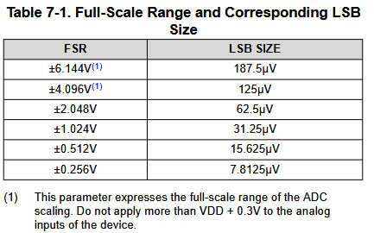

The full scale range depends on VDD, eg. a 3.3V VDD and FSR of 4V means you only get 3.3V, but now with a greater LSB size.

“The ADS111x does not use a traditional band-gap reference to generate the internal voltage reference.”
Now that’s an interesting way to get an internal voltage reference! (That it doesn’t use!)

Programmable datarates! Either 8, 16, 32, 64, 128, 250, 475, 860 samples per second (SPS).

Conversions settle in a single cycle, so conversion time is 1 / DR.

The ALERT/RDY pin has its functionality set by the COMP_MOD Ebit in the Config register. In traditional comparator mode (it uses a DAC), it can go high when conversion data exceeds the limit set in the high-threshold resister, then it goes low when conversion data falls below the limit in the low threshold.

The COMP_MODE configures the comparator as either a traditional comparator or a window comparator. What comparator?

The comparator (it controls the ALERT/RDY pin) can be made to latch with the COMP_LAT bit. This makes it keep state regardless of if what originally triggered it is no longer the case. When, issue and SMBus alert response to clear or reading the Conversion register. (huh? Read conversion register?)

COMP_POL configures it as active high or active low.

Can also configure it as a conversion ready pin.

The ALERT/RDY pin is an open-drain output (meaning the pin is only ever pulled to ground), by default then it’s in a high state I think.

If multiple ADS111x’s are connected, the device with the lowest I²C address always wins arbitration.

The ADS111x reset on power-up, setting all bits in the config register to default settings. After completion of reset, it enters a power-down state (digital blocks are active, but no data conversions). There’s also a reset command.

Two modes (MODE bit in config register):
- Continuous conversion
- Single-shot

Single-Shot:
The device responds to 1b being written into the operational status (OS) bit in the Config register. It powers up (25us process), reads, says data is ready, then powers down until awoken again.

Continuous-Conversion:
When conversion is complete, the result is placed in the Conversion register and another immediately begins. When new configuration settings are written, the currently ongoing conversion completes with previous settings, then new settings are used.

Noise performance of a delta epsilon ADC improves when lowering the output data rate because more samples of the internal modulator are averaged to yield on conversion result. It doesn’t look like this is a SAR ADC.

The IC can be duty cycled to enter a power down state when it isn’t told to read (single-shot). If you have the datarate set to 860 SPS and you single-shot every 125ms, it can sleep for the remaining 123.8ms, 99% lower power!!

I²C is open-drain, ie. devices only drive the bus lines low by connecting them to ground and never drive bus liens high. Pullup resistors drive bus lines high.

SDA carried data, SCL provides clock.

All data on I²C is transmitted in groups of 8 bits.

SDA bits are low=0 high=1.

A value is set on the data line, and after it styles SCL is pulsed high. The pulse on SCL clocks the SDA bit into the receiver shift register.

The controller device always drives the clock line.

Only a controller can initiate a START condition.

Normally, the data line only changes when the clock line is low, if it changes when the clock line is high, this is either a START condition or a STOP condition.

START = SCL high and data goes from high to low.
STOP = SCL high and data goes from low to high.

After the start condition, the controller sets the address byte, indicating which target to communicate with. Each device has a unique 7-bit address. The remaining bit toggles reading or writing from the target device.

Every byte (Address and data) is acknowledged with an acknowledge bit. This acknowledge bit is pulling SDA low, and on an SCL pulse it’s read into the receive register.

When the controller finishes communicating with a target, it can issue a STOP condition. At that point, the bus is idle.

The ADDR pin configures the I²C address of the device depending on if it’s connected to GND, VDD, SDA, or SCL. Now what if there are conflicts? I suppose just don’t do that then, have different I²C busses. This means I’m limited to 4 ADCs on a single I²C bus.

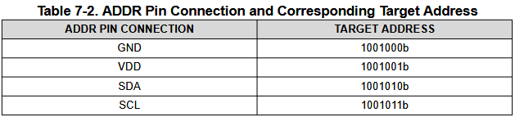

I²C has a general call (0000000b). ADS111x responds to the general call is the eighth bit is 0b. The device acknowledges the general call address and respond to commands in the second byte. If the second byte is 00000110b, the ADS111x reset the internal registers and enter a power-down state.

So does the controller send those two bytes back to back? Is this how to enter a power-down state?

I²C speeds:
Standard: 100kHz
Fast: 400kHz
High-speed: 3.4MHz

High-speed requires activation (unlike others). To active, send 00001xxxb following the START condition. This byte is not acknowledged (I²C spec prohibits acknowledgement of the Hs controller code). Xxx are bits unique to the Hs-capable controller (does this just mean not reused?).

In target receive mode, the first byte is the device address, the second is the Address Pointer register, the next two bytes are written to the given address. All bytes are acknowledged.

Register bytes are sent with most significant byte first.

In target transmit mode, the first byte sent by the controller is the target address (with the R/W bit!). This byte places the target into transmit mode. The next byte transmitted by the target is the most significant byte of the register that is indicated by the register address pointer bits P[1:0]. Then, least significant byte. All are acknowledges and the controller can terminate transmission after any byte by not acknowledging or issuing a START or STOP condition.

I should look into how best to organize components to prevent digital noise from coupling into analog signals, and all the other reasons (is it fine to have USB devices right next to LDO? It must be fine and work but is it proper?).
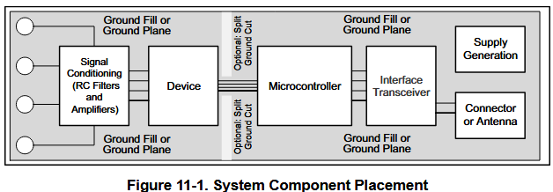

Writing:
Target address byte (with low R/W bit), address pointer register, STOP/START condition.

Reading:
The previous value written to P[1:0] (address pointer register) determines the register that is read. To write a new value to P[1:0], the controller issues a target address byte (R/W bit low), then address pointer register byte. Then, send START condition and send the target address byte with R/W bit high to begin reading.

If you want to continually read the same address, no need to continually send the address pointer register (P[1:0] is stored until modified by a write operation). But, for every write operation the Address Pointer register must be written.

Target address byte (target + R/W bit) -> Address pointer register -> START.

Reading:
- Controller START
- Target address byte (target + R/W bit low)
- Address pointer register (P[1:0])
- Controller STOP (optional? “STOP condition can be issued by the controller.”, no you should send it)
- Controller START
- Target address byte (target + R/W bit high)
- Data Byte 1
- Data Byte 2
- Controller STOP

Writing:
- Controller START
- Target Address Byte (R/W low)
- Address Pointer Register (P[1:0])
- Data Byte 1
- Data Byte 2
- Controller STOP

Note that after each byte during writing, the ADS111x sends the acknowledgement bit.

Four readable registers are accessible through I²C of the ADS111x:
- Address Pointer register (not actual data, just selection)
- Conversion register (result of last conversion)
- Config register
- Lo_thresh,
- Hi_thresh.

Note that target address byte is clearly not a register (obv, but good to remember).

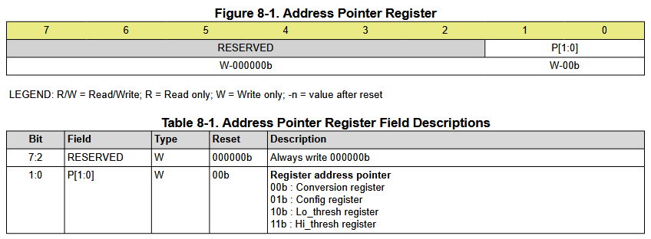
This is What P[1:0] is!!!! Selecting from the four registers!

Default I2C pins in Cube IDE are PB6 & PB7 while on the Nucleo the pins labelled SDA and SCL are PB9 and PB8. Will need to fix in Altium if I want the pinout on the Nucleo to align completely with my board (easier for testing firmware).

Really it’s just the labels that are different, but best to keep it intuitive and change the pins to PB9 and 8.

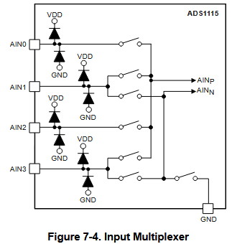

Only one input can be measured at a time (only one ADC core is present).

AIN0 or AIN1 can be measured against ground or AIN3.

Or, AIN0 can be against AIN1 and AIN2 against AIN3.

AIN_{P} is the positive input and AIN_{N} is the negative input.

This is all specified in the programming section:
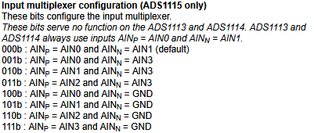

Full scale range: +/- 4.096V means the difference between AINP and AINN can be anywhere in that range. However, input voltages to the IC must be between -0.3V and 5.3V.

So, the range is -4.096V to 4.096V.

High and low threshold has to be changed every time FSR changes.

$uint16_t threshold =\frac{Threshold Voltage}{Full Scale Range}⋅2^{16}$

May 21 2025 - Firmware and Testing of ADS1115
UART Testing:
On the default UART1 pins of PA9 and PA10 (TX and RX respectively), I need jumpers connected to those pins between ST Link and Nucleo to get messages on PuTTY.

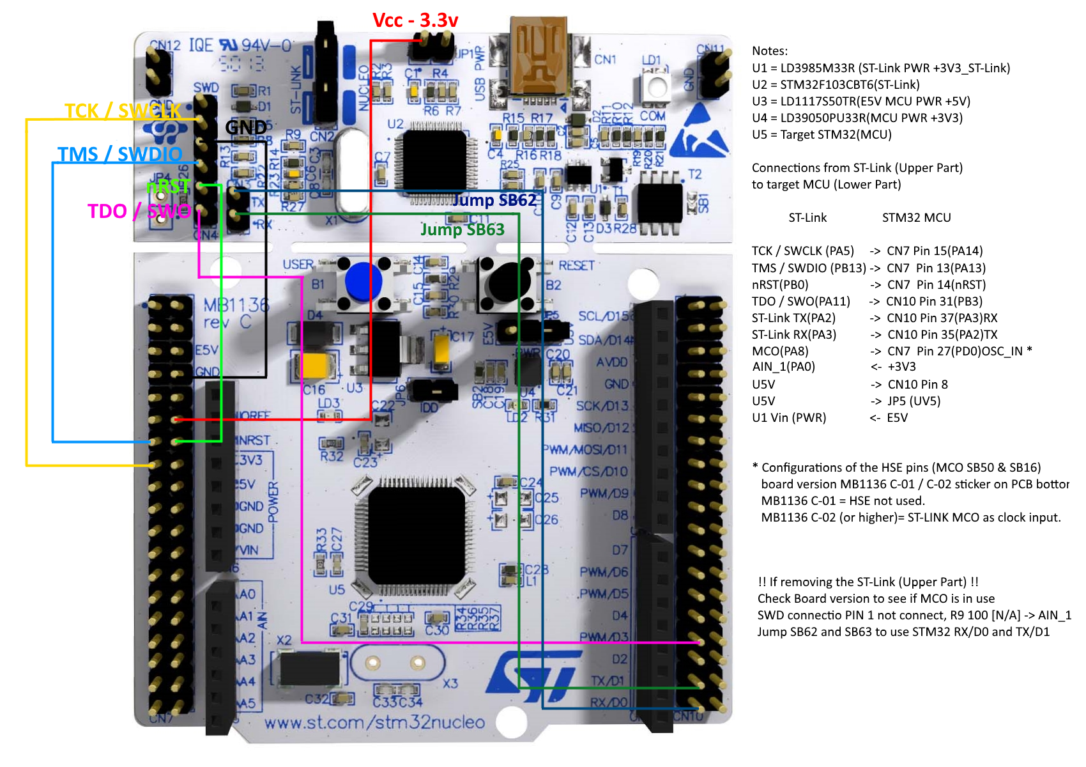
Going off of the above image, PA2 and PA3 (TX, RX) are defaults and are on USART2.

Yes! That worked! So it is PA2 and PA3 that are used on the Nucleo. Now, update Altium accordingly (and that note on the schematic).

On the Nucleo schematics, PA2 and PA3 are connected to the ST Link UART TX and St Link UART RX. Those are the only wires actually connected.
https://youtu.be/isOekyygpR8?si=k5W72Ng8wS1Mgz6j

What the code needs to do:
- Set the config register (init), then lo thresh and high thresh
- Read from the conversion register
- Check the ALERT/RDY pin

It did technically work first try! I was debugging, then bumped the wires a little bit and stopped getting receive errors!

Whatever the issue is, it changes with how I move and place my hands on my desk, so it’s physical so very likely connections which are not an issue on a PCB. Or, noise, which is less of an issue on a PCB and not through jumpers.

If there is an I2C error I need it to init that device again.

I’m getting more weird I2C HAL_StatusTypeDef error 1’s but I’ll assume it’s to do with the wiring because that’s what I’m changing and the result is changing. Good to go for putting it on the PCB, proof of concept complete.

Well, now I need to do timing tests to see how fast I can get data from the various inputs on it.

I just spent an hour and lots of mental suffering debugging and it started working again when I plugged wires in through the breadboard and not directly (Male to Female from Nucleo to the dev board).

So, connections are probably always the issue and this is even more solidified in my mind now. I was skeptical with all the issues, but it was magically fixed when I changed the connections.

While powering the board with 3.3V we expect for ADC readings to work up until 3.3V. We see that we get up to ~31000 and 3.9V, then it gets stuck. At 4.82V we get 32767 and it’s stuck there. It should go up to 65536 (65535?).

Quick testing shows that its very stable!

Tomorrow, characterization and blog post about it, then test multiple inputs on the ADS1115 and how fast you can get data from all of them (if I2C and the STM are fast enough, we should be able to get all four lines at 860 SPS total between them).

860 SPS is 1.16ms between samples, the STM32 should be able to send ~8 bytes over UART in this time.

- 2 Bytes for config for different MUX
  - 4 Bytes for low and high threshold if it’s different for this pin (dynamic range)
- 1 Byte to select register
- Read 2 Bytes.

5-9 bytes over I2C total, not including address bytes.

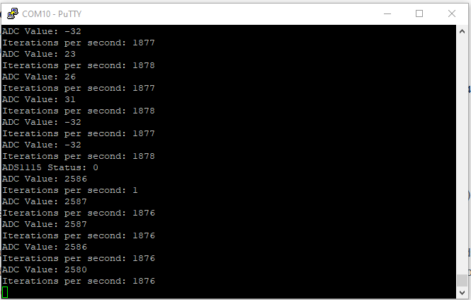
I’m getting 1876 reads per second with nothing else running, we should be fine using DMA.

May 22 2025 - ADC Characterization
Unfortunately the USB port on the front of my HM305 PSU is in fact power only.
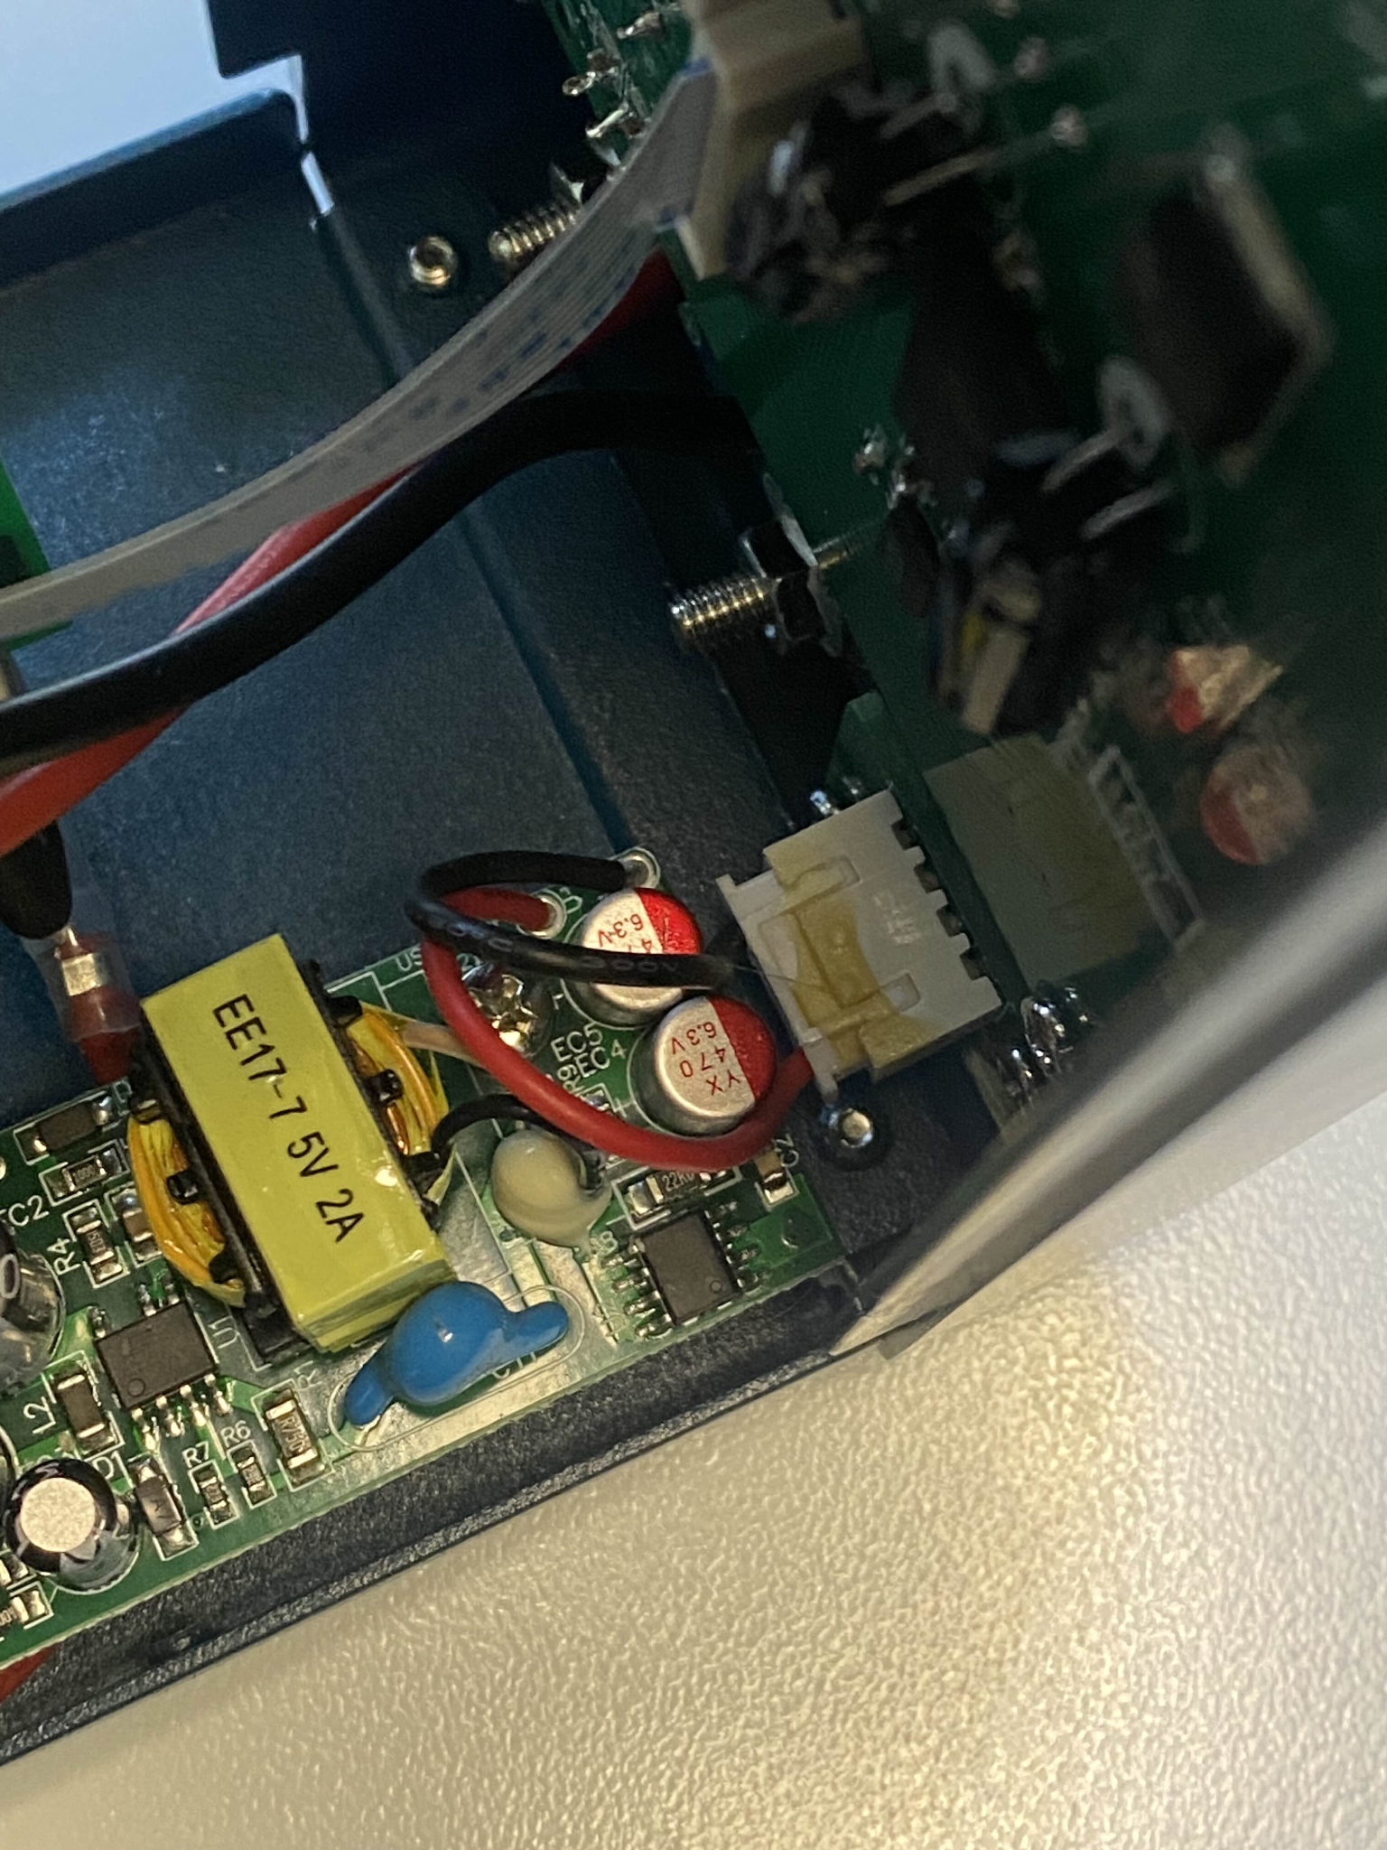

I’ll either need to hack it in some way to make it programmable or do the characterization manually.

ADC Testing Process Screenshot (For blog post):
(Also on Discord in image-file-transfer for high res)
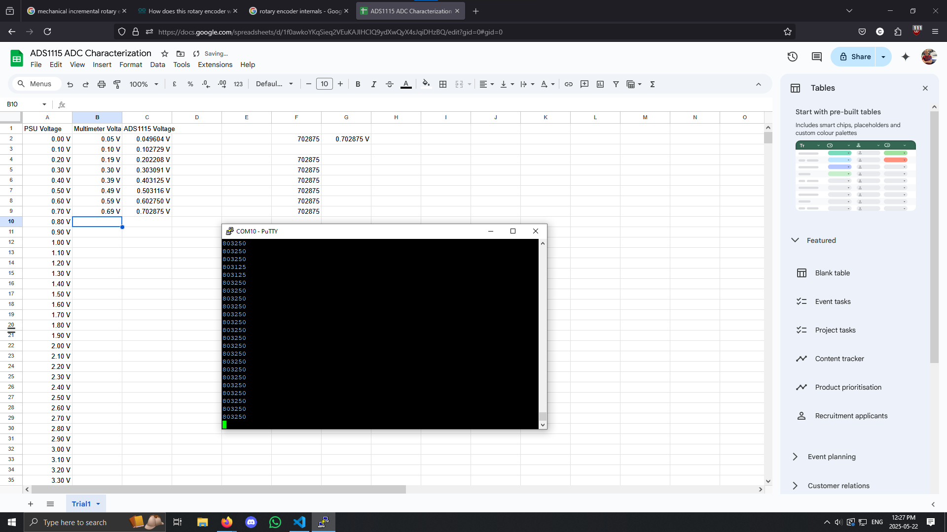

Randomly, I just started getting I2C HAL_StatusTypeDef error code 1:
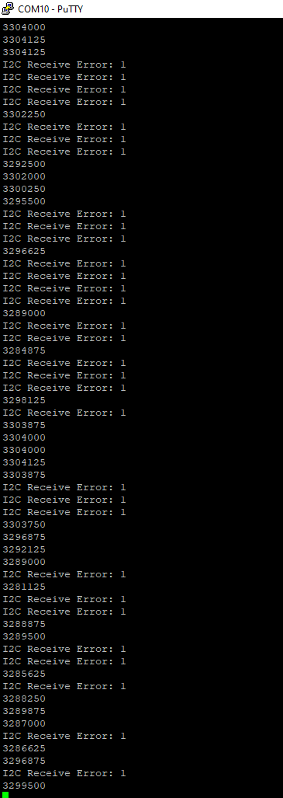

Replugging in the power jumpers solved it

Now when slightly moving the test board, getting bombarded with error 2’s.

Replugging everything fixed it. Likely connection issue again. Nvm error 2’s are back within 10 seconds.

Maybe a power jumper is getting loose and it’s not communicating right, or the pull up resistors on SDA and SCL are not connected to 3.3V on the other side.

With the address line to ground not attached, I get error 1’s.

https://community.st.com/t5/stm32-mcus-embedded-software/why-hal-i2c-isdeviceready-return-hal-error/td-p/186647
I set GPIO_InitStruct.Speed = GPIO_SPEED_FREQ_LOW in stm32f1xx_hal_msp.c and it started working!!

I also soldered pins onto the third ADS1115 test board I bought and got the same error code (1) as the other red board, while the blue board was error code 2.

HAL_OK = 0x00U
HAL_ERROR = 0x01U
HAL_BUSY = 0x02U
HAL_TIMEOUT = 0x03U

In I2C settings, make sure Maximum output speed is low:
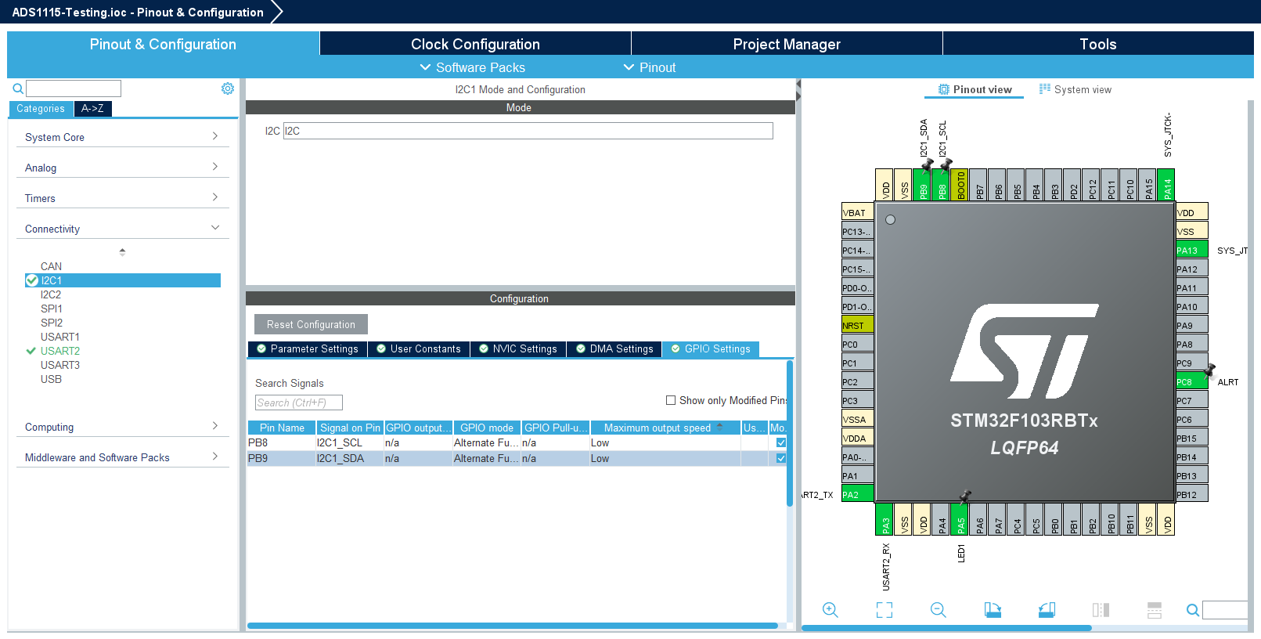

For some reason the blue board is still not working and giving error 2 (busy). If I wrote my own I2C library I could debug better. I’ll just go with the working red test boards.

Right after the last data point I started getting error code 2s (busy). This will require more debugging, now I think it’s likely this is a software issue (the last bug above was software too).

The wires have been changed, the ADC has been changed, the MCU is the independent variable.

If no NACK signals is deterced, the bus can lock up:
https://community.st.com/t5/stm32-mcus-products/i2c-hal-busy/td-p/620525

For some reason if the ADC input are not pulled anywhere, their voltage is ~2.4V.

Have been debugging I2C all day:
https://chatgpt.com/c/682faad0-2010-8006-bda5-b27f48bc87e7

The issue goes away after a few hours and we get good data (code 0 hal status type def).

I don’t actually nee the ALERT/RDY pin to tell me if the reading is above or below some range, this is useless for me, idk why they even added it.

So, no need to set low the high threshold, so 5 data bytes per ADC read.

And the HAL_StatusTypeDef = HAL_Busy error comes up again after 10 minutes of testing.

June 10 2025 - Finding a Current Sensor & Design the Sensing Circuits

From the ADC Characterization:
https://docs.google.com/spreadsheets/d/1f0awkoYKqSieq2VEuKAJlHCIQ9ydXwQyX4sJqiDHzBQ/edit?gid=0#gid=0

We have precision of 125 uV at +/- 4.096 V (i think that range).

mV/A to dA:

Eg 100 mV/A:
100 mV / 125 uV = 800
1/800 = 1.25 mA precision!

Max of 4V means current max of 40 A. Acceptable.

I went with the ACS711ELCTR-25AB-T with +/- 25 A and 55 mV/A.

0.125 mV / 55 mV = 0.00227 A precision
Pretty good!

To all placing components near the banana females since the model has a little bit that juts out:
https://www.altium.com/documentation/knowledge-base/altium-designer/unable-to-move-components-close-to-each-other

June 15 2025 - Conversion Ready
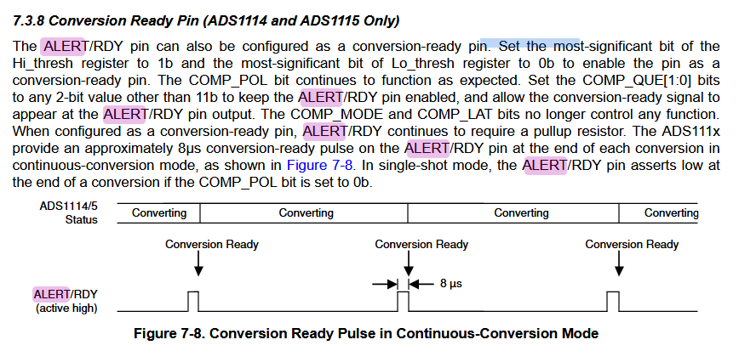
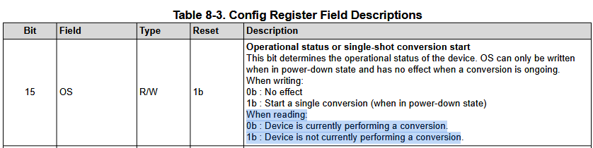

I need to know when to read values if I’m going faster than 860 SPS. Just comparing to the previous value doesn’t work because it might actually be the same. We need to know if it’s stale data or the same value.

Two ways:
1.
Configure the ALERT/RDY pin to go high whenever a conversion is ready, and use this as a GPIO input that triggers an interrupt (EXTI external interrupt). On interrupt, read again. I like this solution!!

2.
Read the OS bit from the config register (more involved and takes longer and I like less but fewer traces! Shift complexity from PCB to firmware, not sure this is the right call here but I’ve already ordered the PCB and this is the only option available to me on this revision).

Make sure to use DMA for I2C and UART to ensure it’s non-blocking.

https://chatgpt.com/c/684f1a68-760c-8006-acd5-4ac0254debb2

I2C bus with 3 ADS1115’s at 860 SPS and 6 bytes per read (3 config, 1 read target, 2 read) should be 30% of 50 kbps limit. Not sure 6 bytes is correct.

Context switching is derived from operating system theory in the 60s-70s.
Context = CPU State
Context switch = saving the state of one task/thread and loading the state of another.

In FreeRTOS let true real-time tasks have the highest priority (eg. EXTI or control loops). I2C reading can be below this, UART either on par or below.

Semaphore = synchronization primitive
Used for signaling between tasks and ISRs (Interrupt Service Routines)
Protects shared resources

Binary semaphore = flag
Counting semaphore = track multiple events / permits (eg. 3 buffers available)
Mutex = mutual exclusion (single resource that only one task can use)

Never call blocking HAL functions in FreeRTOS they block all other tasks too. Blocking FreeRTOS functions are fine they’re implemented differently.

ISRs run outside the task scheduler.
When an ISR runs the scheduler is paused and no context switch can happen until the ISR is finished.
If you spend too long in an ISR you delay ALL task switching.

Best practices for Interrupt Service Routines:
- Keep them short
- No HAL_Delay
- Use xSemaphoreGiveFromISR() or xQueueSendFromISR() to notify tasks
- portYIELD_FROM_ISR() forced a context switch if a task was woken

xSemaphoreGiveFromISR() and xQueueSendFromISR() functions that let an interrupt signal a task. Eg. they allow a peripheral to notify a task it should do something.

FreeRTOS can’t use xSemaphoreGive() or xQueueSend from inside an ISR. “FromISR” is written differently to be non-blocking, atomic, and safe to call inside an interrupt.

Semaphore can unblock a task and Queue send sends data.

A atomic operation is one that completely in one uninterruptible unit.

Since ISRs are run mid-task, semaphores or queues must not leave the system in an inconsistent state.

“FromISR” functions use critical section of architecture-specific atomic primitives (eg. LDREX on ARM) to safely modify internal structures.

A semaphore is a data structure that holds a count (0 or 1 / 0 to N).

xSemaphoreTake() is used in a function to consume a semaphore, if the count is 0, the task is blocked and sits in a waiting list for that semaphore.
xSemaphoreGive() increments the semaphore count if not already 1. Then, any task waiting for it moves into the ready list and is unblocked.

Each semaphore is a data structure with a count and a list of tasks waiting for it.
The waiting list is stored in the internal heap.
So a function “takes” a semaphore and is blocked until that semaphore is “Given” somewhere else.
Heap vs. Stack:
Heap and stack are two different memory regions.

Stack is per-task temporary memory. It grows down into lower addresses and variables go away when the function ends and it’s very fast. Size is fixed.

Heap is a global pool for dynamic allocation.
Shared across system, grows up towards higher addresses, lifetime is manual (eg. malloc(), free()). Slower speed since it searches for free blocks and fragmentation is possible.

Stack is inside a function, heap is global and managed by you.

This is why you don’t need to malloc an iterator variable in a for loop, you wouldn’t put that in the heap.

Each FreeRTOS task has it’s own stack. Kernel objects (eg. semaphore) is on the heap, obv.

You can statically allocated memory in FreeRTOS so it’s all allocated up front, usually global variables. Pre-declared including the task’s stack and control block.

Eg:

xTaskCreate(MyTask, "Task", 128, NULL, 1, NULL); // Uses heap!

static StackType_t my_task_stack[128]; // Pre-allocated stack
static StaticTask_t my_task_tcb; // Pre-allocated TCB (task control block)

TaskHandle_t handle = xTaskCreateStatic(
MyTask,
"Task",
128, // Stack size in words
NULL,
1, // Priority
my_task_stack,
&my_task_tcb
);

Can do the same thing with a parameter for semaphores or queues.

If memory is statically allocated, no fragmentation or allocation failures and faster startup. It’s also deterministic and safer because no need for malloc and free.

Jul 16 2025 - PCB Bringup
Failed one had shorted 3V3 and GND, and I was stupid enough to plug it in, maybe something fried, but after reworking it I couldn’t find the short. 2.1 ohms, then a few minutes later 0.7 ohms between them.

Next one, check shorts after every IC and every component, maybe idk if I’ll be that good

Soldering on the STM32:
- Align the chip onto the pads (and the circle)
- Put some flux on opposing corners of the IC
- With a little bit of solder on an iron, get both corners
- Put flux on all the pins
- With more solder on the iron, get a lot on all the pins
- Short them all
- Solder wick is all off
- Check for shorts using the technique from that one guy
  - Put probe 1 on a pin (on the top)
  - Put probe 2 on the pad, or as far from the IC as possible
  - Multimeter beeps
  - Move probe 2 to the next pin to check shorts between pins
  - Repeat

I’m on the second one now, put on the stm32 and it was fine (checked connections from pin to end, eg. like the LED to the MOSFET circuit, and it was fine), then the USB protection IC thing, was fine, then the LDO and shorted! 3V3 and GND with 0.9 ohms between them!

The VBUS trace from the LDO to the inductor is 0.8 ohms too.

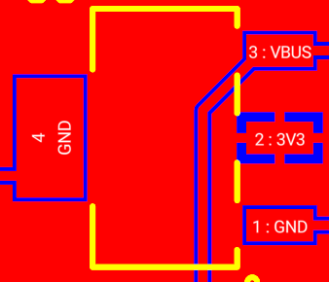
Pin 4 is shorted to 3V3 on an LDO off the PCB (not soldered obv). None of the other pins are shorted.

WTF this is the issue?! Easy enough fix at least, get that big tab (pin 4) removed.

Should’ve consulted the Solar Altium too.
Is it just a heat sink? SOT-89

Datasheet doesn’t say anything about pin 4, and its in fucking chinese.

https://lcsc.com/datasheet/lcsc_datasheet_2411041757_XBLW-AMS1117-3-3-XBLW-SOT-89_C18723569.pdf

Yea it is a heatsink, but why 3.3V idk, maybe internally that line has more heat.

This is the ECU, it has two 4.7 uF caps.
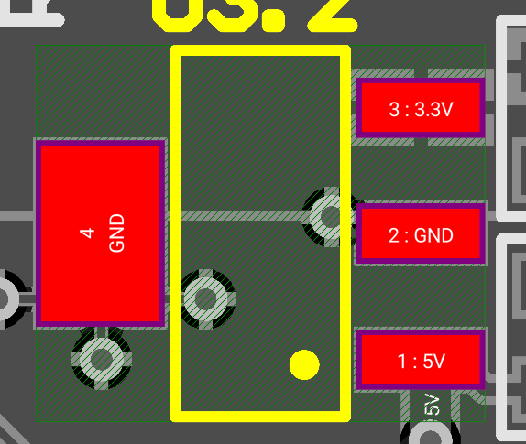

At least the pinout is fine:
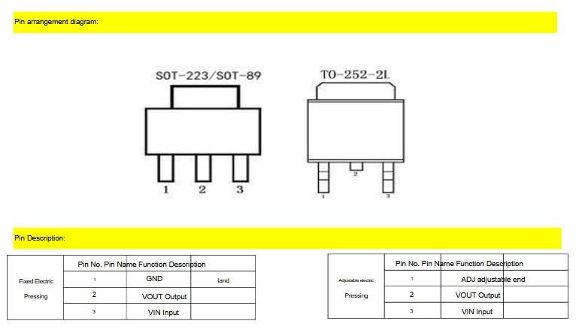

Google Translate has PDF translate btw.

Jul 17 2025 - PCB Bringup

Now 635 Ohms now after cutting off the LDO heatsink tab. Dremel far better than nail clippers here.

On the backup, 770 Ohms but only after scraping at the area with the multimeter probe a bit.

Boot mode pins:
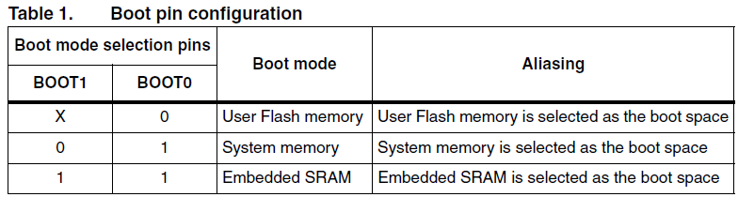

REVISION: Should’ve added a 5V header.

Weird behaviour when powering off a PSU where the USB Bridge and Debug LEDs are far dimmer than 3V3 and current is quickly jumping between 80mA to 200mA. Between samples jumps of maybe 10-30mA, then over time it changes. I have videos.

When powering off UCB the UCB Bridge LEDs (still off 3V3) are a lot brighter, but not Debug LED.

The Debug LED is also pulsing in brightness.
It turns on, increases in brightness over the 0.5s it’s on, then is turned off, repeat.

3V3 LED brightness is also changing, seemingly lower with higher current draw on PSU.

I should get 860 SPS current readings from the IC getting the current it’s drawing itself.

Also, could bring up the second one, and test out the one remaining aliexpress STM32 to see if it was my lack of capacitors that doomed it or the IC itself.

The resistors are correct btw.

With USB power I still see brightness increase while on for 0.5s behaviour on debug LED, but it’s still dim while USB Bridge LEDs are not dim.

Well at least I was able to flash successfully earlier! I can safely move on to writing firmware now and just stay aware of the power issue. Can try with some ICs removed on the extra board too.

Nvm up to 260mA max now after ~10 mins. It does increase with time, starts at around 100mA, now it’s around 200mA after some time of keeping it on.

Now 3V3 is just as dim and current is 160mA, it's not current related. It looks like a loose connection maybe? The brightness pulsation on Debug has gotten worse. Now on USB power too the USB Bridge LEDs are full brightness and 3V# is still flickering and slightly dim, Debug still pulsating.

PCB Problem, or component problem.

REVISION: Would be nice to toggle Debug LEDs on bridge off, or read onto the STM32 (idk how useful that would be). Just toggle the ground with an n channel, so you’d have two n channel on each LED ground.

Milliohm meter:

https://x.com/embedded_emu/status/1941712432336159067?s=46

Would be nice to make a cool enclosure like that. 3D print? Metal and wood?

Jul 18 2025 - Firmware
REVISION: Reverse current protection diode

REVISION: One the Current sensor ADC, keep the unused pins grounded so you have a reference for zero current. Nvm AIN3 is ground! I thought ahead!

Going to use FreeRTOS with DMA for UART and I2C and a custom (maybe existing) library for I2C. Maybe first try the lower level functions for I2C in the STM32 library.

https://grok.com/chat/4e1df0ad-0042-4ae3-a586-80f2c0131202

Create 4 tasks, 3 for ADCs / I2C, and one for UART DMA

Use a mutex so not all can simultaneously write over I2C?
Might need to do something more sophisticated if you’re eg. writing a config of one adc while another is waiting to be read? No, just don’t wait to be read and hold up the mutex, wait in your own task. Only one thing can be done on the I2C bus at a time anyway!

REVISION: Let the ALERT/RDY pin trigger a write and new config send. I already considered this somewhere. June 15.

Got to something useful at the end here, using LL functions to do I2C DMA reads/writes and letting other tasks take the mutex after a bus read is initialized but before we need the data back from the DMA buffer.
https://grok.com/chat/4e1df0ad-0042-4ae3-a586-80f2c0131202

After a DMA I2C read/write is configured, the CPU is free but the bus is not. In this time we let another task start (it is given the semaphore mutex), but this task waits until the I2C bus is ready. When the existing task wants to read its data from DMA, it takes the semaphore back.

https://www.youtube.com/watch?v=OPrcpbKNSjU
Tasks with equal priority are alternated

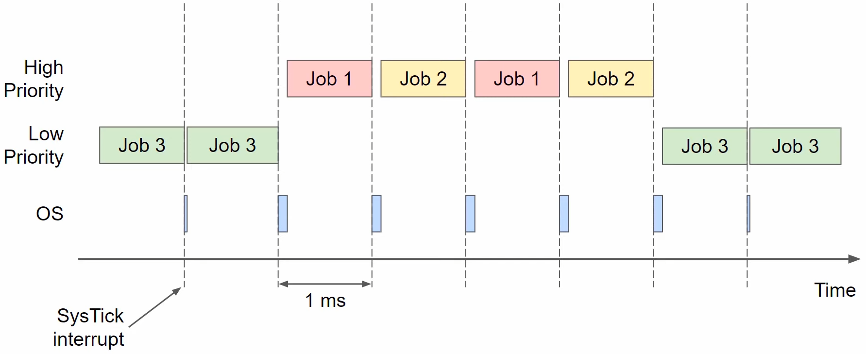

The “x” prefix in functions like xTaskCreate(), xSemaphoreTake() means the function can potentially block and they return a result (success/failure/timeout).

“V” prefix means function never block and return void.

Power consumption started at 36mA this time, already up to 75mA after how long it took for me to open this doc.

For flashing with PlatformIO to work you need to flash the project once with CubeIDE.

Actually nvm, flashing the FreeRTOS project using PlatformIO just doesn’t work.

I reworked the LEDs and MOSFET driver circuits and the behaviour got better.

After about 10 seconds of use I visibly saw the DEBUG LED degrading where while it was off it was still shining. Then it looked like the on state was decreasing in brightness. So off was greater brightness and on was lower. Maybe just a visual effect of staring at it.

Reworking it always fixing the LED momentarily, then it goes back to being shitty (described above).

Looked like USB Bridge LED 1 (GP0) also has the issue of being seemingly off, but in this state slightly increasing in brightness over time.

Also over time I see the DEBUG LED struggling where the low state gets brighter, on states get dimmer, and the brightness ramps when it switches into the on state. It first enters the on state then seemingly increases in brightness, then enters the off state. Shitty mosfet? Idk?

Poking it with a soldering ion while it’s on, I see that if I put the soldering iron on the 3V3 side of the LED its behaviour gets better (full brightness for on state, nothing for off state), but while it’s on it quickly degrades.

If I put the iron on the cathode side the off state gets better (fully off) but the on state doesn’t get brighter. This also disappears after taking the iron off, or even while the iron is on after a few seconds.

Well they are aliexpress LEDs.

After a bit I saw it fully degrade to always at a constant (low ish) brightness.

Fuck its a voltage divider lmao
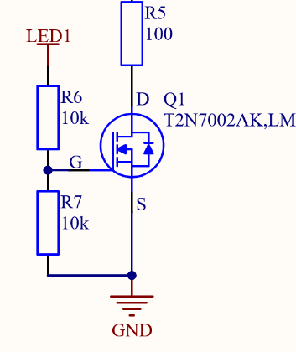

On the ECU it’s a 1k!!!!
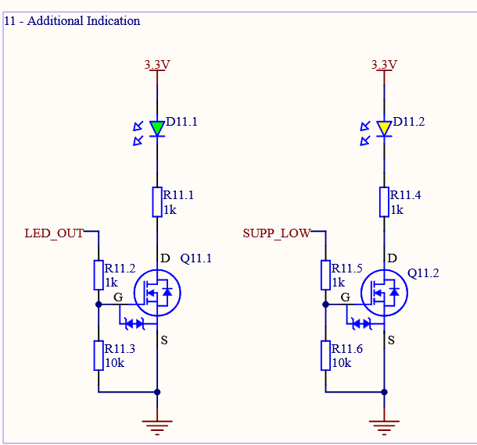

Why put the pull down there? Stupid location for it, don’t create a voltage divider put it on the LED_OUT side, not the mosfet gate side. Eh its best practices just make that a 1k.

Jul 19 2025 - Resoldering
With a 1.65 V MOSFET gate voltage I’d expect strange behaviour, and the difference between 5V USB -> LDO -> 3.3V? Would be different from 3.3 from the PSU

This characterization proves the PSU 3.3V is 3.28 on my multimeter (which to trust is actually non trivial because the ADS1115 matched the PSU more closely than multimeter):
https://docs.google.com/spreadsheets/d/1f0awkoYKqSieq2VEuKAJlHCIQ9ydXwQyX4sJqiDHzBQ/edit?gid=0#gid=0

Any other way to get a high accuracy voltage measurement? Play with diodes? Known current over a known resistor?

With USB Port the USB Bridge LEDs were brighter (I got no photo or video of the old behaviour! Mistake!), so the LDO output is likely brighter than PSU output (maybe it actually is 3.28V).

The LEDs now work perfectly! Fuck they’re immediately degrading. Replug USB and its fine.

The USB Bridge LEDs are the bad ones now and that voltage out of the IC is 2.5V.
It’s powered by VBUS, which is 2.5V while 3V3 is 3.26V. Ok next time 5V test pin is required (couldn’t use just an ST Link then, Nucleo has it though), or power the I2C/UART to USB IC with the 3.3V line.

Logic level high for GPIOs is Vdd, so right now it’s 5V when USB is plugged in.

This also explains why power LED was always fine.
On PSU, Debug LED bad, Bridge LEDs bad
On USB, Debug LED bad, bridge LEDs good

Makes sense!!

Issues:
- Voltage divider MOSFET circuit
- VBUS 2.5V when only 3V3 is powered by a PS

Datasheet in 1.6.2.3 says Vdd and Vusb can both be 3.3V and this disabled the internal LDO.
This is a better design and I should have gone with this option.
REFACTOR: Remember for the future: When a device can be powered off 5V/Vusb or 3.3V, use 3.3V. ST Link has 3.3V and make it all standard.
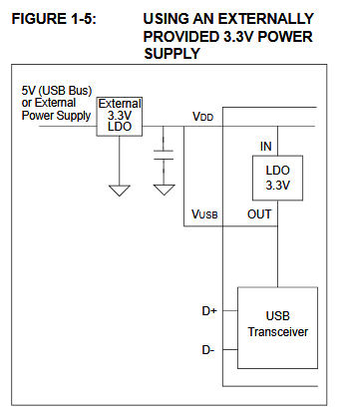

REFACTOR: Another GND pin would be nice so that I can put a multimeter probe to alligator on it while ST Link powered.

Debug LED:
Gate: On: 2.89 V, Off: 0.01 V
GPIO: On: 3.27 V, Off: 0 V

Bridge LEDs flickering, I’ll try reworking with soldering iron the tiny IC.

It doesn’t turn back on after I press the reset button, needs a full power cycle.

Such strange behaviour.
Debugging with dad:
Resistance on the 10k pull down is ~1.6k. Only two paths to ground where I’m probing, the 10k resistor (confirmed 10k after taking it off and probing others) and the MOSFET. Take off 10k and MOSFET (Gate to source, since n mos and gate to ground) shows 16 k ohms. Such a parallel resistor circuit I’d expect 6.15k, maybe with time it recovered slightly or there’s other more inscrutable materials science and physics going on in this failed MOSFET.

Replace MOSFET, now over 10k pull down resistor I get 9. Still some resistor over the MOSFET. Probing extra mosfet on its own and I get nothing even on 20 mega ohm. 9k suggested MOSFET at 100k, fair enough!

Remember The Art Of Electronics principle of letting your circuits not care about exact component values. Should be tolerant of a 10k being 9k.

Replaced DEBUG LED MOSFET and now it looks great! Great success!

GP0 and 1 pull downs are 6.5 with GP2 and 3 are ~9k. Strange, should be fine either way. 1 to 6.5k voltage divider is still good enough to be above Vgs. Lets hope it works!

Letting the MOSFETs sit are just around their Vgs for a while half on.

Now still issues with the IC and not all the LEDs turning on (idk if thats even the expected state), but at least the LED behaviour is expected! Fully on or fully off (or the IC switching states really quickly).

Now GP0 pull down is 1.5k and it’s been on the most. Maybe it’s the IC now???

It always recovers with time, which is the strange thing.

After replacing it was fine for a few minutes, then with the nmos open (GPIO zero voltage) it was still shining. Then, waiting a few minutes, it was fine again.
https://chatgpt.com/c/687c91aa-44f4-8006-b05b-9234bd2fe4d9

I should power the chip through the 5V USB port on the PSU, hopefully this actually shows up with a current on the PSU and isn’t use the 5V trace hooked up to it, otherwise I’ll splice some of my extra alligators into an extra micro usb a that I hopefully have lying around.

On spurious resistance readings:
A multimeter applies a small voltage (often ~0.4-0.6 V). MOSFET gate acts like a floating capacitor and the diode between gate/source or gate/drain can conduct in nonlinear ways, especially if the gate is leaky or partially turned on. Eg. with 0.6 volts over Vgs?
Also, you could be going through the IC, can try taking it off, no good way to do this without a good heat gun.

Will be useful to test this again when it’s working to see if this is just multimeter weirdness or not.

Could try a stronger pull-down on the nmos to see if the LED still shines when gate voltage is supposedly zero.

REVISION: Add diode from VUSB to 5V to block backfeed. Or, jumper to isolate. This seems like too much tbh, diode already is pushing it, just work it into a debug test plan (never do just 3.3V eg, or the IC change mentioned above).

0.7 V voltage drop from 3V3 to VUSB at 2.5 V suggests an internal voltage drop inside the LDO due to some diode, probably internal pass transistor or protection diode.

Try a short instead of the current limiting resistor and a 100 ohm instead of the 10k pull down on the MOSFETs.

The NUF2221 USB termination may be upside down too:
https://grok.com/chat/a37495cf-1f1c-420f-b569-50075789e485
Try shorting over it first? USB Port D+/- to controller +/-/

Jul 19 2025 - More Debugging
I flipped the NUF and now it’s a short, obviously that wasn’t the issue. Trust the dot!

Using the shitty heat gun it can heat up the IC to 160 C. Melting point of leaded solder is 183 C. Shitty.

Couldn’t take off the UART to USB IC, will bring up the other board and compare behaviour.

After heating it up I did get better behaviour over USB, the device showed up a few times but with some error of it not resolving.

Jul 23 2025 - More Debugging
Bringing up another board
Idk how many ADS1115’s I bought, but I’m putting one from the 6x string on the very bottom, two good ones on top. I took a picture of this.

So if I see a difference in accuracy, I know if its the Digikey chips or Aliexpress chips. Will probably be fine though.

Brought up the next one fully. Still similar issue.
First, GP1 is not lighting up even though the GPIO is high. Reworking. Still not working, voltages are off too. Gate is ~2.4 and its not on.

Even taking off the current limiting gate resistor the GP3 LED is still slightly on.

Putting a short instead of the pull down and its still slightly on. 1V on the other side of it. 3.26 V on the positive side of the LED, 1.15 V on the other. Work a working LED it’s 0.5 V on the other side.

I soldered on a female jumper to the 5V line and turned it on. ~0.33 A of current draw. Smoke coming out of the STM32. I’ll extremely quickly probe 3V3 voltage now.

It’s a steady 3.29, the LED is flashing, but the chip is heating up and I might be able to smell it. Also, 0.35 - 0.5 A current draw now.

3V3 and GND is shorted now??? 25 Ohms.

3.3 V / 25 Ohms = 0.132 A. Maybe it is the chip.

Yea it is heating up and now I can smell it. 14 Ohms. FUCK. Holding reset button did nothing.

It must be the soldering on the STM32. I feel it heating up in the upper left corner. Check the connections there.

One minute later, resistance is 2.5 ohms now.

Reworked the area and now 250 Ohms. Worked and LED blinked and current started at 80 mA.

When the source voltage started to dip (5V source). It went back down to 4 ohms.

What is causing the high current draw must be the STM32 then. It’s the independent variable. Now why does the current draw increase.

I could try subtracting ICs to find the issue. Maybe rework the second board I made. Maybe just go for the other board and figure out the LED issues. I haven’t even gotten to USB yet holy fuck.

Jul 23 2025 - Some NMOS Research
NMOS Saturation:
- V_{GS} > Vth (MOSFET is on)
- V_{DS} >= V_{GS} - Vth

I_{D} (drain current) because nearly independent of V_{DS} and is controlled by V_{GS}:

$I_{D}=\frac{k}{2}(V_{GS}-V_{th})^{2}$

The MOSFET regulates V_{DS} current, sourcing current from the drain.

For V_{GS} = 4V and V_{th} = 2.1V (from datasheet), make sure V_{DS} < 1.9V to stay in the linear region (conducting the way you want it to).

Aug 31 - Debugging & Consulting The Machine God
Going to need to put more effort into talking to it, might require MCP2221A drivers and need to send specific commands to get UART working because of the variable BAUD rate.

USB Specification requires max 10 uF across VBUS and GND. See section 1.6.2.2. I’ve got a few 10 uF’s on the board, two on VBUS. One of these is for the IC the other is for the LDO. Far higher effective capacitance might make the USB controller not accept the connection during enumeration.

MCP2221A datasheet wants the RST pin pulled up by a 10k to VBUS. I pull it to 3.3 V, which may be incorrect.

Note that both the MCP2221A and the NUF have 1.5k USB data pull up resistors. The NUF has a 22 ohm termination resistor as well.

The VDD / VBUS capacitor on the MCP2221A is recommended to be 0.22-0.47 uF ceramic. I have it at 10 uF now, might be terrible. See section 1.6.2.2 again.

I read max 10 uF as use 10 uF. Incorrect.

I think I wired the NUF wrong, Grok is saying pin 1 (D+) should go to the connector. I have it going to the MCP. The datasheet shows the NUF on USB Controller-side (I think this means host?).

Double check later - I’m right and the datasheet backs me up it’s fine, I’ll assume it’s hallucination

Default GP settings (from Grok):
- GP0: LED_URX (active low)
- GP1: LED_UTX (active low)
- GP2: USBCFG (active low lights when USB enumeration complete!)
- GP3: LED_I2C (active low, I2C traffic indicator)

I get GP2 lighting up, which means GP2 is positive, which means USB enumeration is not complete. I assumed it was active high, so I expect LEDs to be off when things are going well.

To keep V BUS capacitance below 10 uF, I need a different LDO that supports 4.7 uF on the input. This is what the Nicleo does.

Next steps:
- Remove RST pull up to 3.3V and replaced with pull up to VBUS
- Replace MCP cap with 220 or 470 nF instead of 10 uF
- Possibly replace LDO capacitor with 4.7 uF instead of 10 uF, if USB enumeration still fails.

For now it’s also possible to just work on the firmware while using an ST-Link for UART.

